**Wisconsin Council of the Blind and Visually Impaired Council Courier, Fall 2022**

**In the Fall 2022 issue of the Council Courier:**

* **Windows to More Than the Soul: The Importance of Routine Eye Exams**
* **Letter from Executive Director Denise Jess**
* **Building Awareness in Three Courses: Plus Dessert**
* **Building on the Momentum of White Cane Safety Day to Promote Safer Streets for All Pedestrians**
* **New Faces at the Council: Welcome to debbie rasmussen and Rachel Pavone**
* **Upcoming Events**
* **About Us**

**Windows to More Than the Soul: The Importance of Routine Eye Exams**

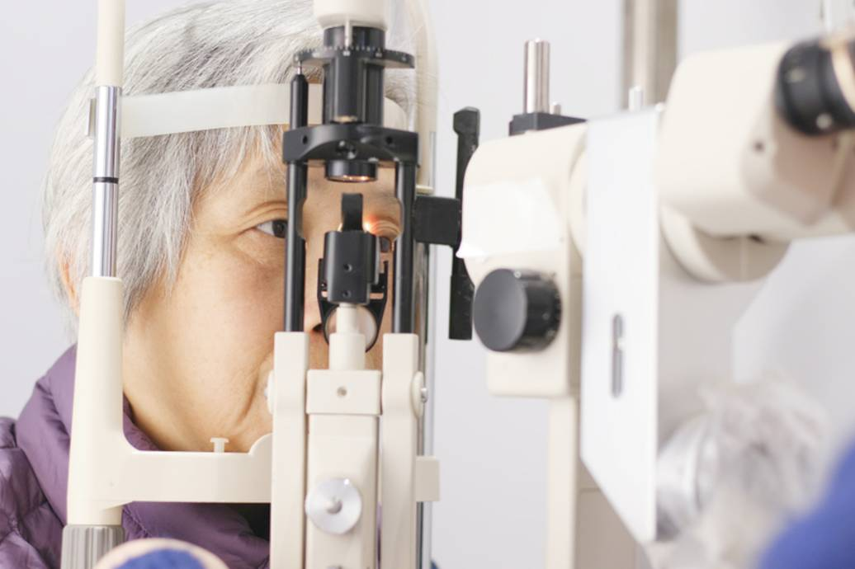

Photo: A woman having her eyes examined

You’ve probably heard the old saying “The eyes are the windows to the soul.” To a trained eye doctor, the eyes are also windows to the rest of the body and its overall health.

There are many reasons it’s important to have routine eye exams. Some of them are obvious: Monitoring your eye health, protecting your vision, and detecting eye conditions at an early stage when they can be treated most effectively. But an eye exam can also reveal clues about health conditions that affect the rest of the human anatomy.

Dr. Kallie Harrier, an optometrist with Isthmus Eye Care in Madison with expertise in low vision, explains that a lot of problems centered in the eye don’t have any symptoms. One common example is glaucoma, often referred to as “the sneak thief of sight.” Many patients aren’t aware anything is wrong until they’ve already started to lose vision. Routine eye exams where pressure inside the eye is tested are the only way to detect glaucoma before it starts to cause irreversible damage.

“In glaucoma, early detection is key because it’s a disease that progresses slowly and we can do something about it,” Dr. Harrier says. “The sooner we can start you on your eye drops or other treatment the better, because that’s going to reduce the risk of future progression of the disease.”

Even with other eye diseases that are less treatable than glaucoma, such as retinitis pigmentosa or macular degeneration, early detection can lead to the best outcomes.

“There may not be a cure that we can offer but knowing about the condition helps people prepare for what’s coming,” Dr. Harrier says. “The sooner we can acknowledge what’s happening with their vision, the better position they’ll be in to adjust to the changes.”

More surprising to many people is that the list of conditions an eye exam can uncover goes far beyond the eyes. High blood pressure and diabetes are two health problems that are often first identified by an optometrist or ophthalmologist.

“A lot of people, especially if they don’t have health insurance, skip their routine physical exams, but they’ll come to us because they can’t see well and they need new glasses,” Dr. Harrier says. “And then we find a systemic condition like diabetes or high blood pressure. There have been multiple times where I’m the first person to see diabetes in a patient, and then we can refer them to their primary care provider to get the treatment they need.”

How are eye doctors able to discover these conditions? It turns out that the eyes really are like windows in a sense. They provide a unique view of the body’s inner workings.

“The cool thing about the eye is that it’s the only place in the human body where we can see blood flowing through your veins without having to cut you open,” Dr. Harrier explains. “We can tell a lot about a person’s overall health just by looking at that vasculature. With high blood pressure, instead of nice smooth blood vessels, we often see them get kinked or start to change course because of that increased pressure over time.

“Sometimes we’ll see blood in the back of the eye that shouldn’t be there, and that can be an indication of diabetes,” Dr. Harrier added.

Abnormal blood flow isn’t the only type of warning sign a doctor can observe through the eyes.

“Just a couple weeks ago, I had a patient come in for a routine exam just to get some new contact lenses,” Dr. Harrier said. “I found swollen optic nerves, so I sent her to the emergency room, and she had emergency surgery that day to remove a brain tumor. So there are a lot of things we see in the eye that reflect what’s happening throughout the body.”

Dr. Harrier emphasizes that it’s important to continue getting routine eye exams even if you’ve already been diagnosed with and are being treated for a particular eye condition.

“I tell my patients ‘You can have as many diseases as it pleases,’” she says. “That means just because you have glaucoma doesn’t mean you can’t also get macular degeneration, or just because you have diabetic retinopathy doesn’t mean you can’t get glaucoma.”

For people with a new diagnosis of a condition that threatens their eyesight, Dr. Harrier says it’s beneficial to see an optometrist who specializes in low vision to make sure you get the best lens prescription possible.

“A lot of times, people are just resigned to not seeing well, but even a little bit of glasses prescription can make a big difference,” she says. “If you have access to a low vision optometrist, they can help you get the best vision possible and help you find the tools you need. And if there’s a tool we can’t provide, we can refer to an organization like the Council that may be able to help.”

**Further Reading**:

American Academy of Ophthalmology, “20 Surprising Health Problems an Eye Exam Can Catch,” tinyurl.com/EyeExamCanCatch

Centers for Disease Control and Prevention, “Keep an Eye on Your Vision Health,” tinyurl.com/KeepEyeOnVisionHealth

AARP, “8 Health Problems That Can Be Detected Through an Eye Exam,” tinyurl.com/8ProblemsEyeExams

**Letter from Executive Director Denise Jess**

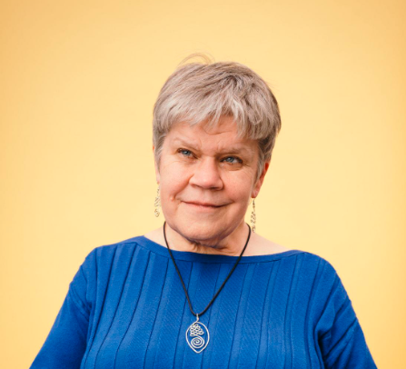

Photo: Executive Director Denise Jess

**Speaking Out for Our Voting Rights**

Assuring the rights of voters with vision loss is an important advocacy priority for the Council. With the mid-term elections just weeks away on November 8, we encourage everyone to understand your rights and to make your voting plan.

**Absentee Voting:** If you plan to vote absentee, please do so several weeks before the election to ensure that your ballot is received at your polling place no later than 8:00 p.m. on Election Day. With the delays in mail delivery, we suggest mailing the ballot at least two weeks prior to the election. Remember that you will need to have your ballot witnessed and the certification envelope signed by both you and your witness. If someone is assisting you in completing your ballot, this must also be noted. Your assistant and witness may be the same person. Due to recent administrative rules changes, clerks can no longer “cure” small errors, like adding a forgotten zip code, on the certification envelope. Please have your witness carefully check that all information is accurate on the return envelope.

Wisconsin currently does not have a way for people with vision loss to vote absentee privately and independently, as we are still reliant on having someone else complete our ballot on our behalf. The Council will continue our work to advocate for an accessible absentee ballot in the 2023-24 legislative session.

**Ballot Return:** After the Wisconsin Supreme Court ruling in the Tiegan case in June that resulted in disallowing the use of ballot drop boxes and limiting ballot return, there was confusion among both voters and election officials on whether a voter could have someone else return their ballot. A recent federal ruling assures the rights of voters with disabilities to receive assistance in returning their ballot. This assistant can be anyone of the voter’s choosing except the voter’s employer or union representative.

**Accessible Voting Equipment:** If you vote in person, Wisconsin law guarantees the right to use the accessible voting equipment in the polling place. This equipment uses both screen reading and magnification technology to make the ballot readable for people with print-related disabilities. While this equipment should be set up, fully functional and tested when the polls open, we hear countless stories from around the state that voters run into access barriers when attempting to use the equipment. We encourage you to contact your clerk in advance of the election to let them know you plan to use the equipment and that you want to be sure it is ready and that poll workers have had proper training in its use.

**Voting Assistance:** Wisconsin law also guarantees the right of voters with disabilities to ask for assistance in completing the ballot. This is a person of the voter’s choosing, excluding the voter’s employer, union representative or a candidate on the ballot. Poll workers are required to assist when asked. Voters have shared with us that some poll workers have declined to assist, believing that they were not allowed to help. This is inaccurate.

**Other Accommodations:** All polling places should be equipped with signature guides, magnifying glasses and chairs for sitting. The Council has helped advocate for the Wisconsin Elections Commission to facilitate a supply program where any clerk can order large print signs, signature guides, magnifiers, doorbells and other accessibility supplies at no cost to the municipality. Ask for these tools if you need them.

**Encountering an Access Issue:** If you encounter an access issue while at the polls, ask to speak with the Chief Elections Inspector to resolve it in real time. The Chief Elections Inspector is the “supervisor” of the polling site. If you are not satisfied with the resolution, ask to speak with your clerk.

**Disability Rights Voter Hotline:** If you are unable to resolve an issue with your local officials and need assistance, call the Disability Rights Voter Hotline at 844-347-8683.

**Sharing Your Voting Story:** We’d love to hear your voter story. If an election official provided excellent support so that you could fully exercise your right to vote, we’d love to help celebrate this. If you experienced difficulties, these stories assist in our advocacy efforts. You can use the Share Your Story form on our website at WCBlind.org/news/#story. You can also email your story to Communications Director Bob Jacobson at BJacobson@WCBlind.org or call Bob at 608-237-8111.

Also consider reporting your experience to the Wisconsin Elections Commission using their accessibility concerns page at tinyurl.com/WIElectionConcern. While we hear many stories directly from voters, having them documented with the Elections Commission is a vital component in advocating for change.

As people with vision loss, it’s critical that our life experiences, perspectives and needs are represented in our local, state and national governing bodies. Our votes matter in this November mid-term election and in every election.

Building Awareness in Three Courses (Plus Dessert)

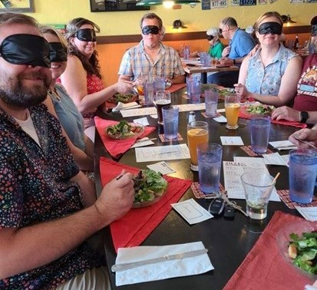

Photo: A table of blindfolded diners eating salads at Beastro & Barley

Caption: Blindfolded diners at Beastro & Barley enjoying their salads

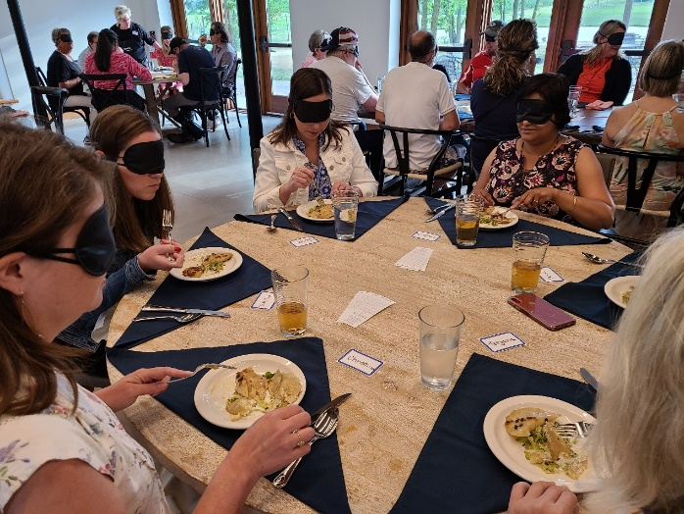

Photo: Blindfolded diners at Four Winds Farm enjoying their meals

Caption: Diners digging in at Four Winds Farm

Kari Walker, chef and co-owner of the Reedsburg restaurant Beastro & Barley, was enrolled in the Culinary Arts program at Madison College when she got her first taste of Dining in the Dark a few years ago. It started with a visit from Council Executive Director Denise Jess.

“I got to hear Denise talk about making restaurants more inclusive,” Kari says. “Making pathways so that people can safely navigate, for example.”

The next day, the Culinary Arts program hosted a Dining in the Dark event, at which Kari was a server. “I was just so moved,” Kari says. “It was a powerful experience for the servers and the participants.”

Dining in the Dark is a unique culinary experience where patrons enjoy their meal while blindfolded. Typically, some participants are visually impaired, but most are not. The idea is to provide diners an opportunity to experience an excellent meal relying on senses other than sight, allowing them to focus more on texture, aroma and subtle flavors. The other idea is to raise money to support the Council’s work; the organization receives after-expenses proceeds as a donation.

Kari points out that patrons aren’t the only ones who gain new insights through Dining in the Dark. There are revelations for restaurant staff as well. Servers gain a stronger understanding of the accessibility needs of their patrons as they discover the importance of introducing themselves before approaching a diner and arranging food in ways that are easy to describe verbally. “We take things a little slower, and we’re more thoughtful and careful in our movements,” she says.

Randy Pierce is a longtime customer at Beastro & Barley. He knows the owners and servers, and they know he is visually impaired. Kari had been accommodating all along, but after she attended the Madison College program, “it turned on a light,” Randy said. “She started consciously doing that. It was very nice.”

“With the increasing number of people who are aging and experience vision loss, just knowing how to be more thoughtful in how we serve our guests is helpful,” Kari adds. “Everybody can use those skills across the entire customer base. It doesn’t just have to be a person who is visually impaired.”

The Council has been collaborating with restaurants to host Dining in the Dark events since 2013, bringing them back in 2022 after a two-year break. Dining in the Dark meals usually consist of three or four courses plus dessert. Guests remain blindfolded through most of the event and are not told the menu ahead of time; courses are described only after the first few bites. Each course incorporates a variety of smells and textures to provide a full sensory experience.

After dinner, Council staff members lead discussions about enjoying food using senses other than sight and answer questions about cooking and eating with vision loss.

Four Winds Farm hosted its first Dining in the Dark under the leadership of events coordinator Mark Wroczynski this summer. Mark has hosted many previous dinners and has observed some changes in guest behavior. “Guests seem more adventurous, curious and willing to participate,” he says. “With no visual cues to let them know portion sizes, guests tend to eat all that is put in front of them. It’s a chef’s dream come true!”

Like Kari, Mark values the opportunity to better understand some of the challenges of dining with vision loss. “Many attendees have little awareness of what those with visual impairments have to deal with at dining establishments,” he says. “It is inspiring to witness that moment the light bulb goes off and their facial expressions change with acknowledgement.”

If you are interested in attending or hosting a future Dining in the Dark event, contact Lori Werbeckes at LWerbeckes@WCBlind.org or 608-237-8114.

**Building on the Momentum of White Cane Safety Day to Promote Safer Streets for All Pedestrians**

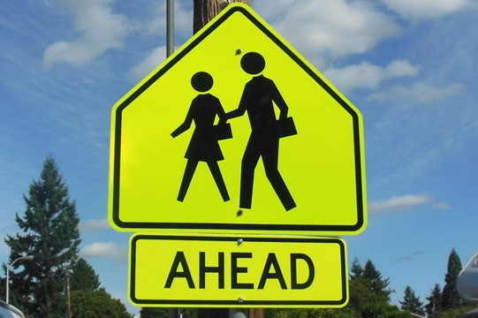

Photo: A yellow traffic sign showing a pair of pedestrians and the word Ahead

Since 1964, October 15 has been designated nationally as White Cane Safety Day. White Cane Safety Day is an opportunity to raise awareness of Wisconsin’s White Cane Law, which requires drivers to stop at least 10 feet from a pedestrian using a white cane or service dog. Every year, the Council works with local leaders to officially recognize White Cane Safety Day through a formal proclamation. Last fall, leaders in 23 Wisconsin communities joined Governor Tony Evers in formally proclaiming October 15 White Cane Safety Day.

Building awareness of the White Cane Law is important in itself, but we understand that it will take much more than a once-a-year push to make our streets safer for pedestrians. Bringing about meaningful change requires a long-term, multi-faceted, strategic effort, and we believe White Cane Safety Day can be a springboard to a much more ambitious campaign. So this year, we’ve raised the bar and are taking the opportunity to promote pedestrian safety on a broader scale.

This summer, the Council wrote to those 23 local elected officials thanking them for their commitment to pedestrian safety and offering ideas for building on the momentum of White Cane Safety Day. Our suggestions, in addition to issuing a proclamation, included:

* Creating a “Vision Zero” plan aimed at eliminating traffic fatalities through comprehensive, cross-disciplinary local planning and cooperation.
* Joining a community member on a “[walk audit](https://nam02.safelinks.protection.outlook.com/?url=https%3A%2F%2Fwww.aarp.org%2Flivable-communities%2Fgetting-around%2Faarp-walk-audit-tool-kit.html&data=05%7C01%7Cbjacobson%40wcblind.org%7Cea41ffb1f6e24cd67f9208da2eaf2655%7Cc09f627a22a7445bbc7b8cc3f354b051%7C0%7C0%7C637873627049018280%7CUnknown%7CTWFpbGZsb3d8eyJWIjoiMC4wLjAwMDAiLCJQIjoiV2luMzIiLCJBTiI6Ik1haWwiLCJXVCI6Mn0%3D%7C3000%7C%7C%7C&sdata=j9OW%2BJH%2BDd%2BpzM5lftIvZ%2BYdwwxwc5OE3fx7wTjyUdw%3D&reserved=0)” to evaluate how accessible our streets are for pedestrians.
* Initiating plans to make a troublesome intersection safer by installing pedestrian safety features such as crossing signals.
* Checking out the [Wisconsin Department of Transportation’s Non-Driver ArcGIS Online Application](https://nam02.safelinks.protection.outlook.com/?url=http%3A%2F%2Fwisconsindot.gov%2FPages%2Fprojects%2Fmultimodal%2Fnd.aspx&data=05%7C01%7Cbjacobson%40wcblind.org%7Cea41ffb1f6e24cd67f9208da2eaf2655%7Cc09f627a22a7445bbc7b8cc3f354b051%7C0%7C0%7C637873627049018280%7CUnknown%7CTWFpbGZsb3d8eyJWIjoiMC4wLjAwMDAiLCJQIjoiV2luMzIiLCJBTiI6Ik1haWwiLCJXVCI6Mn0%3D%7C3000%7C%7C%7C&sdata=CZiHsNgxHtxyRg0tHJwsXdeHfscI9PNZUeIxLHQ1Z9Y%3D&reserved=0) and encouraging city planners to use this valuable tool to gauge transit needs and allocate pedestrian resources.

Now we’re working to expand the number of municipalities taking part in the movement. We’ve also reached out to our network of grassroots advocates, asking them to encourage leaders in their communities to make pedestrian safety a top priority. And in early September, we collaborated with Sierra Club-Wisconsin Chapter and 1,000 Friends of Wisconsin on a webinar, “Make Way for Pedestrians,” that outlined strategies for improving pedestrian safety in your community.

If you’re interested in joining the effort and helping promote pedestrian safety in your community, you can find a White Cane Safety Day Toolkit containing sample letters, social media posts and other resources on the Council website at WCBlind.org/white-cane-safety-day/.

**New Faces at the Council: Welcome to debbie rasmussen and Rachel Pavone**

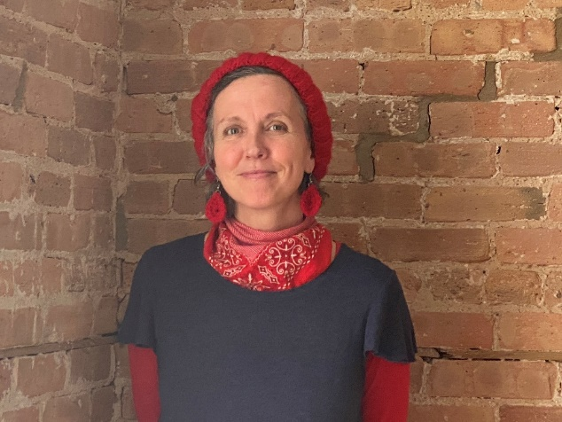

Photo: debbie rasmussen standing in front of a brick wall

Caption: debbie rasmussen

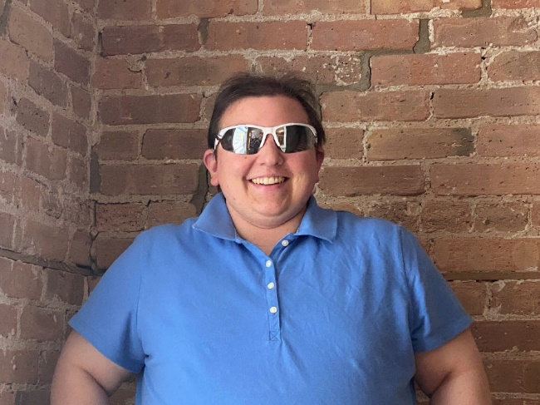

Photo: Rachel Pavone standing in front of a brick wall

Caption: Rachel Pavone

The Council is pleased to welcome two new members to the team!

Debbie rasmussen joined the Council staff in April as Fund Development Coordinator, working side-by-side with Fund Development Director Lori Werbeckes. Debbie’s role is to maintain donor records and support fundraising efforts in a variety of other ways.

Debbie holds a B.A. in psychology from the University of Minnesota and an M.A. in journalism from the University of Wisconsin-Madison.

Debbie deeply appreciates sunshine, warm weather, reading, writing, making music, preparing vegan food and spending time with animals, and she’s passionate about housing cooperatives and other forms of communal living.

“I discovered my love of fundraising while working as director of a nonprofit feminist media organization,” debbie says. “Doing something I love in support of the Council’s important mission is an exciting opportunity.”

Rachel came on board in June as a Vision Rehabilitation Therapist. In that role, she collaborates with clients who are blind or have low vision to educate them on ways to accomplish independent living tasks, introducing them to new methods and assistive devices to help with daily activities. Rachel was instrumental in the development of the Council’s new on-site Vision Rehabilitation Classroom, where she began working with clients earlier this fall.

Rachel has a Bachelor of Science degree in general studies and a Master of Arts degree in Vision Rehabilitation Therapy, both from Western Michigan University. When she is not working with clients, she loves to play with her guide dog Glory and play jazz on her alto saxophone.

“Through my own life experiences, I realized that I wanted to help others who are blind and share the learning opportunities I benefitted from that they may not have had growing up,” Rachel says.

Welcome to the Council, debbie and Rachel!

**Upcoming Events**

**White Cane Safety Day, October 15**

October 15 is recognized nationally each year as White Cane Safety Day. The Council takes this opportunity to promote safe, welcoming communities for people with vision loss, educate the public and policymakers about the White Cane Law, and advocate for greater pedestrian safety everywhere.

**Gallery Night, November 4**

Our annual Gallery Night highlights the amazing art created by people from across Wisconsin living with vision loss. We’re returning to an in-person event format after two years of virtual gallery nights. Visit WCBlind.org/gallery-night/ for more information and to view art from last year’s Gallery Night.

**Back Cover:**

The Council publishes four monthly e-newsletters: Upcoming Events, Advocacy Update, On Sight and News You Can Use. Each has important information to help empower readers living with vision loss to live vibrant, independent lives. Subscribe to any or all of them at WCBlind.org/newsletter-signup/.

Did you know that the Council Courier is also available in large print, braille and audio formats? To request an alternative format or update your mailing address, call us at 608-255-1166.

**Contact Us**

754 Williamson St.

Madison, WI 53703

WCBlind.org

Info@WCBlind.org

608-255-1166

800-783-5213