**Wisconsin Council of the Blind and Visually Impaired Council Courier, Spring 2024**

**In the Spring 2024 issue of the Council Courier:**

* **Sharper Vision Store Offers a Supportive, Well-Informed Shopping Experience**
* **Letter from Executive Director Denise Jess**
* **Grants Are Putting Adaptive Products in the Hands of Clients Who Need Them**
* **Welcoming the Council’s Newest Board Member, Maggie Groshan**
* **Helping Prepare Young Visitors for Work, Life and Democracy**
* **Your Gift Will Change a Life**
* **Upcoming Events**
  + **Birding by Ear**
  + **Dining in the Dark**
  + **Advocacy Day**
* **Back Page**

**Sharper Vision Store Offers a Supportive, Well-Informed Shopping Experience**

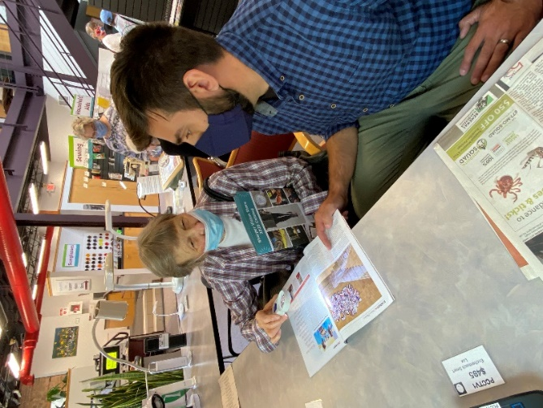

Photo: Customer Care Specialist Greg Schmidt helps a Sharper Vision Store customer.

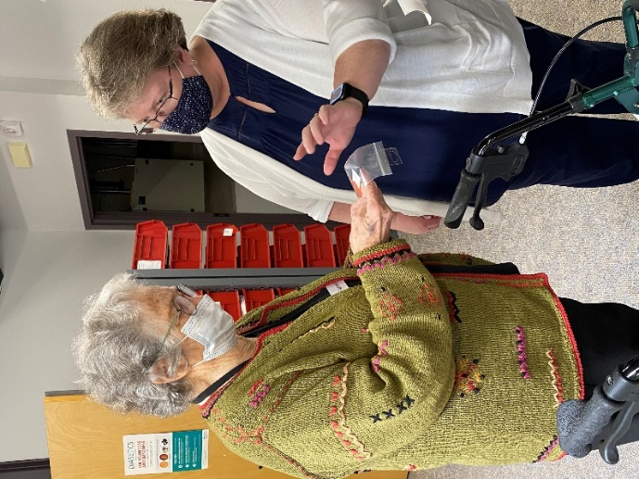

Photo: Education and Vision Services Director Amy Wurf gives a customer advice about a store product.

Someone once said, “The internet may give you what you want, but it won’t give you what you need.” Whether it’s surfing for accurate product reviews or purchasing a pair of shoes that fit properly from Amazon, internet shopping can be a true “buyer beware” endeavor.

There’s no substitute for an actual storefront staffed with knowledgeable people. The Council’s Sharper Vision Store has the staff and the inventory to help you make informed choices and smart buys.

Greg Schmidt is the Sharper Vision Store Customer Care Specialist. He knows firsthand the advantages of a store visit over an internet search. “Shopping with us, you have that one-on-one experience of testing products to see if they work,” he says. “Online, you’re not quite sure what you’re getting.”

Greg uses magnifiers as an example. Often a buyer who uses some random internet store will receive a different magnification level than what they ordered. And even if they receive what they ordered, not having the ability to try it out first may lead to sending it back.

“You might luck out and find something appropriate,” Greg concedes, “but here you can try different items to find something that works best, and you have someone who’s knowledgeable standing right there to answer your questions or point you to another option on the shelf that might fit your needs better.”

Those in-store options are another key advantage to shopping at the Sharper Vision Store as opposed to, say, a big chain drugstore. They may only keep two kinds of magnifiers in stock. The Sharper Vision Store carries many different models.

Sharper Vision Store shopping also provides advantages to people who are buying products for others. Often a family member, with the best intentions, will pop on Amazon and buy a product for a family member or friend with a visual impairment. But the potential for aggravation or a drawer filled with unused items is pretty high.

“I can’t tell you how many things we see unused in people’s houses,” says Amy Wurf, Education and Vision Services Director at the Council. “Family members mean well, but it’s often not helpful.” Amy frequently hears comments like “My grandchildren gave me this and I don’t have the heart to tell them that it’s not right for me.”

In addition to being an opportunity to make an informed purchase, Greg sees coming into the Sharper Vision Store as a gateway to the services the Council offers in conjunction with the products. Vision service professionals are right there in the building and can even schedule home visits to make sure a customer is getting what they expect and need from the items they buy. Greg says listening carefully to a customer is a large part of his job.

“You pick up cues from somebody struggling with a product,” Greg says. “Those cues may tell me that the customer may need more training to use the product effectively.” For example, when a customer reveals that they’re having trouble with their work on a computer, Greg can offer to coordinate a visit with the Council’s Access Technology Specialist, Jim Denham. Or he can refer somebody who is using a white cane for the first time to Certified Orientation and Mobility Specialist Brent Perzentka for training. Amy, a Certified Low Vision Therapist, can provide a functional low vision evaluation to help them understand how to make the best use of lighting and magnification products.

Greg notes that working with first-time shoppers can be especially gratifying. He says he greets them with a series of questions in his head. Where are they at? What needs do they have? What is becoming more difficult for them? A first-time customer may be in the middle of a challenging emotional transition.

“Emotional terrain can range anywhere from depression to confusion to anger,” Greg says. “That’s where reading the room as to where they’re coming from emotionally is so important. As an individual who runs the store, my main goal is to build trust, not to draw a higher profit margin. Instead of trying to maximize revenue, we’re focused on an accurate and honest assessment of what the customer’s needs are. At the end of the day, we’re here to help, not sell you a product.”

**Letter from Executive Director Denise Jess**

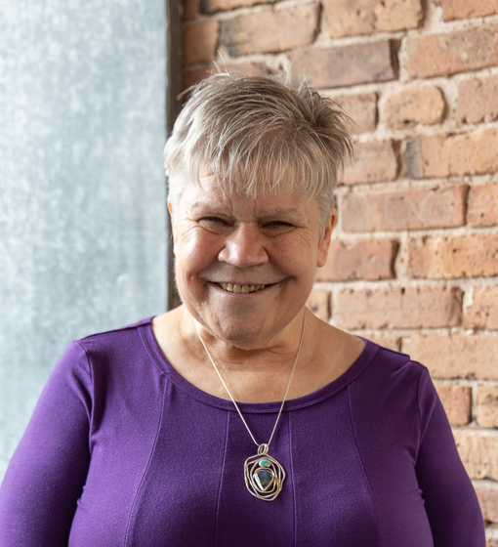

Photo: Denise Jess from the shoulders up in front of a brick wall

At the Council, we are grateful that our vision services, education and advocacy efforts make a difference in the lives of Wisconsinites with vision loss. When a client gets a piece of adaptive equipment into their hands or learns a new skill that makes their life easier and brings enjoyment, it is exciting to hear the relief and satisfaction in their voice. When there is a policy shift that reduces or removes a barrier and positively impacts many of us across the state, we rejoice.

This work is powered by our donors, some of whom have been with the Council for more than 35 years while others are just beginning our relationship. These gifts, both small and large, matter.

Funding sources for adaptive products and instruction are extremely limited. In most situations, they are not covered by Medicare, Medicaid or private insurance, leaving people to either pay out of pocket or go without. With 37% of older adults with vision impairments living on incomes of $20,000 or less annually, many people would be forced to forgo these life-changing services. While public funding does pay for some fee-for-service, it is not equal to the costs of providing that service. Due to narrow program eligibility criteria, many people do not qualify for these public programs.

The Council has always been committed to serving people regardless of their ability to pay. We know that these services allow people to stay in their homes safely, continue working, participate in hobbies, and maintain physical and mental well-being.

If you have given to the Council recently, thank you!! If you are not a current donor, please consider becoming one today.

With gratitude,

Denise

**Grants Are Putting Adaptive Products in the Hands of Clients Who Need Them**



Photo: A magnifier showing the list of ingredients on the label of a can of corn.



Photo: An extra-long oven mitt

The Council serves a clientele that is diverse in every way, including economic status. That means it’s easier for some than others to afford the adaptive products they can benefit from. Aware of these financial shortfalls, the Council seeks grants from charitable foundations and other funders. Funds we receive enable us to provide products that enhance safety and assist with daily living tasks at no cost to clients who cannot afford to purchase them on their own.

In the past year, we’ve received funding for this program from the Brotz Family Foundation, the Courtier Foundation, the Endres Manufacturing Foundation, the Green Bay Packers Foundation, Herb Kohl Philanthropies, Only in Wisconsin Giving - New Glarus Brewing Company, the MG&E Foundation, and Walmart - Monona Store.

The grants ranged in size from $500 to $5,000. The Council is grateful to all these funders for their support!

Fund Development Director Lori Werbeckes says, “These grants make it possible to customize what items clients receive according to their specific situation.”

That doesn’t mean providing everything a client might benefit from, however. “We can’t offset the cost of every product,” says Education and Vision Services Director Amy Wurf. “What we can do is work with the client to help them decide what is most important for them.”

Products the Council has provided through this program include bump dots to mark controls on kitchen appliances; handheld magnifiers to read prescription labels, mail or package instructions; talking clocks and watches; sunglasses; and kitchen tools like large print measuring cups.

“Our clients are always very grateful for this assistance,” Amy continues. “Many times, they will offer to pay a portion of the cost when assistance is discussed, or they let us know that they will pass the generosity forward when they are able.”

Benita Cooper is one of those grateful clients. The Madison area resident says Council staff members have really been there when she needed them. “They helped me very much,” she says. “And they provided all types of items for my low vision.”

Benita mentions that among the products the Council has provided, large print calendars and a low vision reader have been especially useful. “And they helped me learn how to use them,” Benita adds.

Sarah Evans is a client who has turned to the Council for a variety of vision services, including Orientation & Mobility (O&M) training, Vision Rehabilitation, and Access Technology instruction. While working with Sarah at her home on white cane skills, the Council’s Brent Perzentka, who is certified in both O&M and Vision Rehab, was able to help her address some other safety and daily living needs. Thanks to the foundation funding, Brent was able to provide Sarah with several adaptive kitchen items, including an oven mitt, a safe peeler, a talking kitchen thermometer, and a fill sensor that beeps when a coffee cup is full.

“The thing I use the most is a spatula that’s really more like tongs,” Sarah says. “It’s hard to flip when you can’t see, but if you can grab it from the top, it flips easily. Those things have made a great difference, and I’m grateful.”

If you know of an organization or foundation that would be interested in supporting this unique client-driven program, contact Lori at 608-237-8114 or [LWerbeckes@WCBlind.org](mailto:LWerbeckes@WCBlind.org).

**Welcoming the Council’s Newest Board Member, Maggie Groshan**



Photo: Maggie Groshan smiling for the camera

A very warm welcome to Stoughton resident Maggie Groshan as she begins her term as the newest member of the Council’s Board of Directors. Maggie brings first-hand experience as a client of the Council. “I did some work with (Access Technology Specialist) Jim Denham, and he thought I’d make a good board candidate,” Maggie says.

Maggie has also participated in the Council’s College and Working Age Low Vision Support Group. It was that experience that inspired her to seek a seat on the board, as she began to understand how much work there is to do. “I was shocked at how many people in their adult life have lost their sight and have no good resources to find ways to adjust,” Maggie says. “I’m quite passionate about being an advocate to help people find the resources they need to be independent, or at least be able to help themselves.”

“As I start my term on the board, some things on my mind are continuing to move forward on making transportation more accessible for everyone, and making sure that those who are blind or visually impaired can receive an education with the help of the Council’s scholarship program,” she added.

“I want everyone to know that I want to work hard to make sure the Council is around for generations to come,” Maggie says. “It’s an organization that’s helped so many people, including myself.”

Executive Director Denise Jess says Maggie’s background makes her an excellent fit. “She’s going to bring a great perspective to the board as a parent of a young child and as someone very highly motivated to increase her skills,” Denise says.

Board Chair Nick Sinram of Milwaukee is also excited to welcome Maggie aboard. He’s also mindful of the demands and responsibilities that come with board membership. “We try to be flexible and understanding that people are volunteers,” Nick says. “It’s a balance of lifestyle and work.”

**Helping Prepare Young Visitors for Work, Life and Democracy**

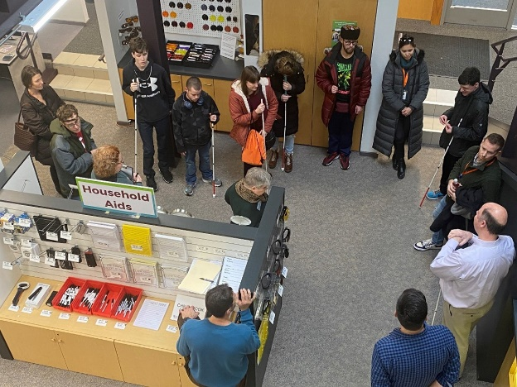

Photo: Students and Council staff standing in the Sharper Vision Store

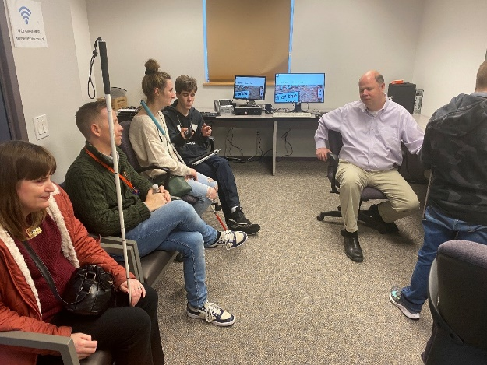

Photo: Jim Denham and visitors in the access technology classroom

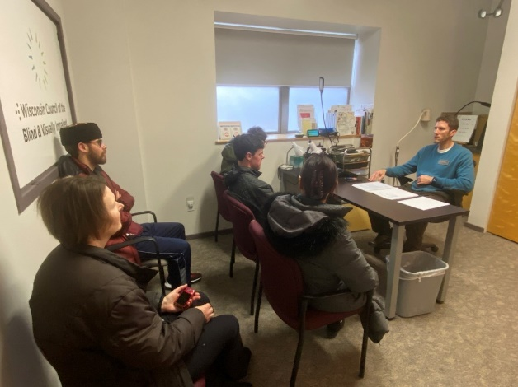

Photo: Brent Perzentka with a group of visiting students

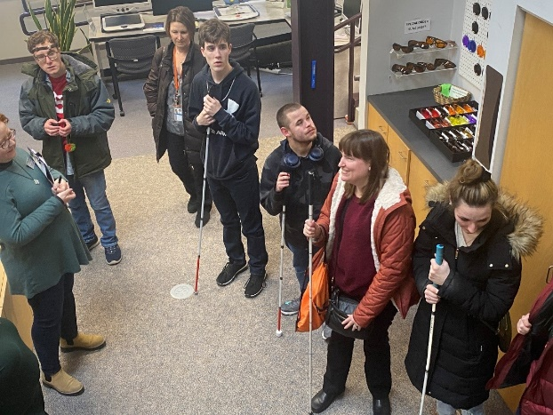

Photo: Visitors standing in the Sharper Vision Store

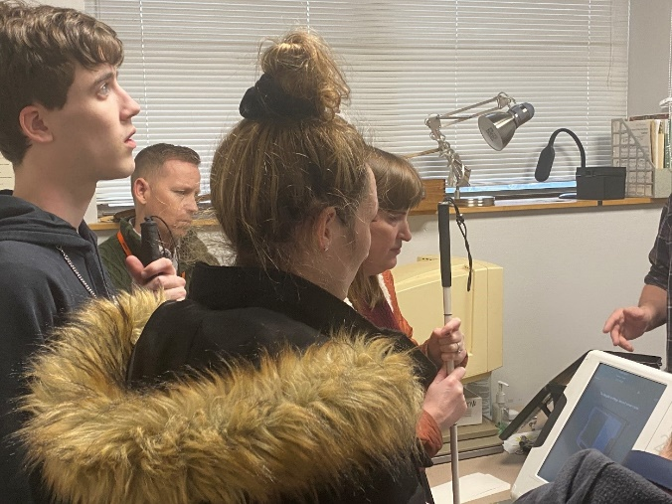

Photo: Students exploring an accessible voting machine

Things are always buzzing at the Council offices. But recently a different kind of buzz was heard when the Council hosted a visit by students from the Wisconsin Center for the Blind and Visually Impaired in Janesville. The six students, members of a College and Career Readiness class, and four staff members came to the Council to learn about our services as they prepare for the transition from school to adulthood and into the workforce.

The visitors got a tour of the Sharper Vision store and met with Council staff to talk about a range of topics, including orientation and mobility skills for learning a new neighborhood or campus; access technology for the workplace; and career opportunities in vision services. In addition, City of Madison staff were on hand to demonstrate an accessible voting machine.

**Your Gift Will Change a Life**

**Immediate Gifts**

* Cash or credit card; checks made payable to the Wisconsin Council of the Blind & Visually Impaired, Inc.
* Online giving is available at www.wcblind.org.
* Monthly giving is easy to set up and much appreciated.
* Gifts in honor or in memory of a friend or loved one.
* Double your gift! Check if your employer (current or former) has a “Matching Gift Program.” Many employers will match gifts to charities.
* IRA distributions and gifts from Donor Advised Funds.
* Stocks and other appreciated assets.

**Planned Gifts**

* Bequests and other deferred giving methods – include Wisconsin Council of the Blind & Visually Impaired in your will or trust.
* Life insurance - name the Council as a beneficiary of your insurance policy.
* Annuities – provide for the future of the Council and receive interest payments for a lifetime.

**Join Us**

**White Cane Circle** members give monthly gifts through their bank account, credit card, PayPal or check.

**Friends of the Council** contribute $500 or more in a calendar year. This could be a one-time gift, monthly giving or a combination of support that adds up to $500.

**Legacy Circle** members have communicated their intent to benefit the Wisconsin Council of the Blind & Visually Impaired through a bequest, insurance gift, charitable gift annuity or another planned gift. Please notify us if you have already made such arrangements.

**Every gift to the Wisconsin Council of the Blind & Visually Impaired makes a difference**. Contact Lori Werbeckes, Fund Development Director, at (608)237-8114 or by email at [LWerbeckes@wcblind.org](mailto:LWerbeckes@wcblind.org).

*“Sometimes when we are generous in small, barely detectable ways,*

*it can change someone else’s life forever.” ~Margaret Cho*

**Upcoming Events**

Birding by Ear

Learn to identify birds using senses other than sight. On **Saturday, May 4**, we’re teaming up once again with Southern Wisconsin Bird Alliance (formerly Madison Audubon) to present this unique educational opportunity. And we’re adding a new partner to the mix this year—Aldo Leopold Nature Center. Open to birders of all experience levels with and without disabilities.

Learn more and register at [SWIBirds.org/All-Events/2024/5/4/Birding-by-Ear](https://swibirds.org/all-events/2024/5/4/birding-by-ear).

Dining in the Dark

Dining in the Dark is an experiential dinner that challenges attendees to rethink the importance of vision in the dining experience. The Council partners with restaurants across the state to host Dining in the Dark fundraisers. Guests are blindfolded during the multi-course meal.

A Dining in the Dark event is currently scheduled for this spring on **Monday, May 13 at Brix Cider** in Mount Horeb; Visit [WCBlind.org/Events/Dining-in-the-Dark](https://wcblind.org/events/dining-in-the-dark) for more information.

Advocacy Day

Join us on **Thursday, May 16** for this moderated panel discussion where you will hear from three advocates with different levels of experience focusing on a range of issues. Watch our newsletters, website and social media for registration and other details coming soon!

For registration and other information, visit [WCBlind.org/Events/Advocacy-Days](https://wcblind.org/events/advocacy-days).

**Back Page**

Did you know that the Council Courier is also available in braille and audio formats? To request an alternative format or update your mailing address, call us at 608-255-1166.

The Council also publishes weekly e-newsletters that include features, helpful tips, advocacy information, upcoming events and more. You can subscribe at [WCBlind.org/Newsletter-Signup](http://WWW.WCBlind.org/newsletter-signup) .

**Contact Us:**  
Wisconsin Council of the Blind and Visually Impaired  
Address: 754 Williamson Street  
Madison WI 53703  
Website: WCBlind.org  
Email: [Info@WCBlind.org](mailto:Info@WCBlind.org)608-255-1166  
800-783-5213