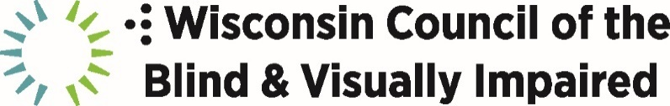

754 Williamson Street, Madison, WI 53703 · 608-255-1166

**Contact:**Bob Jacobson, 608-237-8111, BJacobson@WCBlind.org

FOR IMMEDIATE RELEASE

**Wisconsin Council of the Blind & Visually Impaired Announces 2024 Scholarship Recipients**

July 26, 2024 – The Wisconsin Council of the Blind & Visually Impaired has awarded $2,000 scholarships to six Wisconsin students with blindness or low vision who are pursuing postsecondary education during the academic year beginning this fall. The Council, founded in 1952, has been offering scholarships for most of its history to students with vision loss.

This year’s scholarship recipients are:

**Jasmine Bertschy, Valders, UW-Whitewater**

**Marin Kylie Gundlach, Belleville, Madison College**

**Jayquan Jaeger, Madison, UW-Madison**

**Miso Kwak, UW-Madison**

**Kaylee Mueller, Campbellsport, UW-Green Bay**

**Mia Zutter, Sun Prairie, Northern Illinois University**

“It’s a privilege to help these inspiring young scholars overcome the significant educational and career obstacles all people living with vision loss face,” says Executive Director Denise Jess. “Our scholarship program exemplifies the Council’s mission of empowerment. With appropriate accommodations and support, blindness and low vision need not prevent people from pursuing the life they choose.”

The Wisconsin Council of the Blind & Visually Impaired is an independent, statewide nonprofit that promotes the dignity and empowerment of Wisconsinites living with vision loss through advocacy, education and vision services.

To learn more about the Council, visit [www.WCBlind.org](http://www.wcblind.org/).

*###*