Council Courier, Fall 2024

Header: Don’t Say “Over There”: How to be a Better Describer for Someone who is Blind or Low Vision

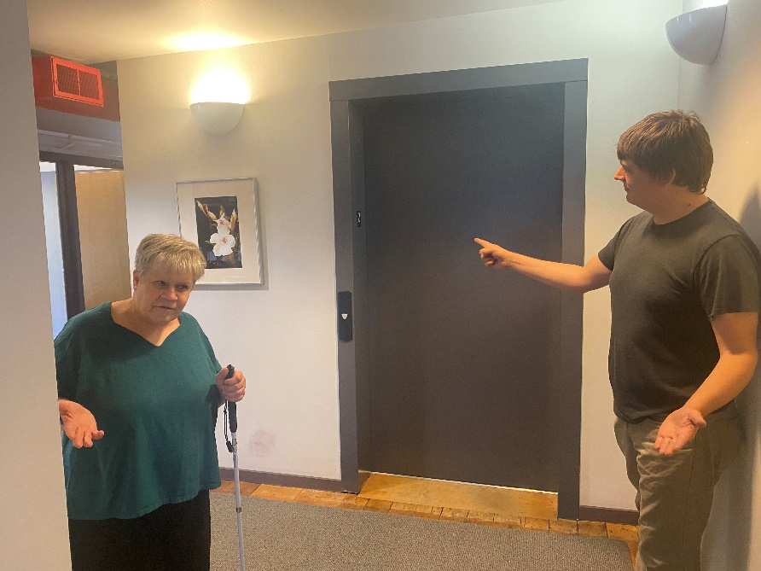

Alt text: A sighted person attempting to direct a person with a white cane toward an elevator by pointing at it.

When someone in your life loses their vision, it can be hard to know how to describe things to them. For instance, telling someone with little or no functional vision that a chair is “over there” isn’t going to do them much good. Much of our standard language for describing things is visually based. But with a little practice, you can get better at describing what and where things are to people who are blind or low vision.

The most important thing to do when learning how to be a better describer is to ask the person how they want something described. Everyone is different, and what works for one person may not work for someone else.

For Access Technology Specialist Jim Denham, who is blind, clarification is key. He says that when something is being described to him, directional information is the most useful. “Let’s say I’m approaching a doorway,” Jim says. “Having someone say, ‘It’s a little bit to your right’ will be helpful.” Jim says the direction and an estimate of how far away something is will usually be enough for him to find where he needs to go.

Jim says he doesn’t like it when a well-intentioned person grabs him by the arm or by his cane to walk him to where he’s trying to go. While he doesn’t mind holding someone’s arm to be guided somewhere, it’s always important to ask before touching another person. If you are leading someone with physical touch, have them hold onto your elbow or upper forearm. Never try to lead someone by their cane, since they are relying on feedback from the cane to know what is in front of them.

While Jim likes to know how far away something is, Council Board Member Rebecca Arrowood says distances sometimes just trip her up. Instead, she prefers landmarks, like being told to take a left at the coffee shop. That gives her a concrete location where she needs to turn. The more detail, the better.

When being shown around a new office building, Rebecca says she first likes to be shown the basics, like where her office is, where the stairs and elevators are, and where the bathrooms and kitchen are. “Then as we are taking our tour, it’s helpful for someone to tell me what room we are in so I know that to get to my office from the elevator, I need to walk through the kitchen and hallway. Knowing the floor layout is really helpful.”

While good location descriptions are critical, it is equally important for the person who is blind or low vision to speak up and say what does and doesn’t work for them. “You have to get comfortable asking for more details,” says Executive Director Denise Jess of the Council. “For a lot of people, there is a whole internal narrative of ‘I don’t want to have to ask, or make a big deal out of this,’ particularly for people who are newly experiencing vision loss. People should understand that it’s okay to ask for what you need.”

Denise says that when she is having a place described to her for the first time, context is everything. For example, Denise says she recently went to the veterinarian’s office and asked for the bathroom. The receptionist told Denise it was down a hallway, the third door on the right. “It was succinct, it was clear, and it didn’t include any details I didn’t need,” Denise says. “I was able to find it easily.”

One thing Denise does not like is when someone does something for her without being asked. When she’s asking where the ketchup bottle is, it’s so that she can grab it herself. “To me, that feels like you are saying I’m incapable of finding the ketchup bottle myself. I just want the information I am asking for,” Denise says.

Most people are not intentionally describing things poorly, Denise says. By speaking up and saying what works for you, you help the describer know what to do next time.

“It’s all a very personal thing,” Jim adds. “Some people who are newly blind may want you to just show them. For me, I want to build independence, but it really depends on how comfortable you are as a traveler.”

Header: Letter from Executive Director Denise Jess

Subhead: Seeing Beyond the Troubling Numbers

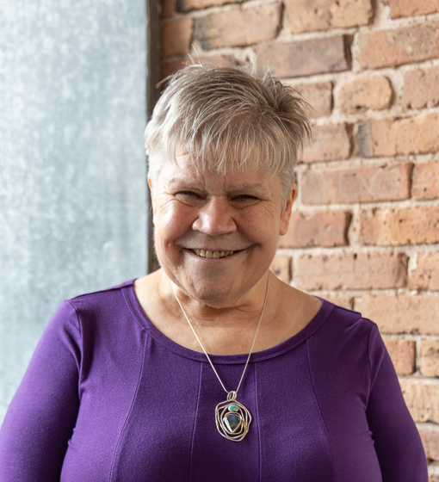

Alt text: Photo of Denise Jess.

Over the past couple of years, two groundbreaking reports have been published on the population of people who are blind or low vision, one last year focusing on older adults and most recently a companion report looking at our working-age people. These reports come from VisionServe Alliance using big data sets from the U.S. Census Bureau and the Centers for Disease Control.

Thanks to support from the Council, Vision Forward, Beyond Vision and Industries for the Blind & Visually Impaired, we have access to Wisconsin-specific information to go along with the national picture. This issue of the Courier includes an article summarizing the findings from the working-age report and its implications for our advocacy work.

These reports contain population numbers and percentages, racial and gender breakdowns, and an overall snapshot of the health, income, education and employment challenges faced by our state’s blind and low vision community. Upon my first reading of the reports, I found the data deeply concerning. I felt sad and angry at the poor quality of life many in our state experience. In our work as a service provider, we see these challenges every day, and as a blind person myself, I’ve faced some of them. But reading the actual numbers took my breath away.

We’ve been advocating for the development of these types of reports for many years, knowing that data opens doors. We are remarkably good at sharing stories of our life experiences with decision-makers in both the public and private sectors—stories that open the people’s hearts and give them a peek into our world. However, personal stories alone are not sufficient for spurring system change. So often I’ve been asked for solid data by policy makers and business owners, but I could only provide gross approximations of the number of people who are blind or low vision and are employed or unemployed. It was not enough to move the needle. While we were making progress, the steps were small and incremental.

Now, armed with both powerful stories and numbers, the conversation is shifting. Many of the strong working relationships we have established through our coalitions have become stronger. New relationship pathways are being forged with key policy players in our state agencies and at the national level. We have common language for joining the conversations about health, income and race disparities. And we can elevate the issues faced by people who are blind and low vision into a deeper commitment to changing systems to provide greater access to vision services and to reduce transportation, employment and health care barriers. We have a long way to go, but more and more I have the feeling of joining a positive, forward-moving stream, rather than fighting the upstream battle to have our concerns considered.

As you read the article on the Big Data report on working-age adults, you may feel some of the same things I felt initially—sad, frustrated, overwhelmed—and that’s understandable. But we hope it will also inspire you to help share it, use it to raise awareness, and join us in our advocacy efforts. We invite you to be part of that growing positive stream to promote dignity and empowerment for people who are blind and low vision.

Header: Big Data Working Age Adults Report Paints Sobering Picture, Highlights Need for Advocacy

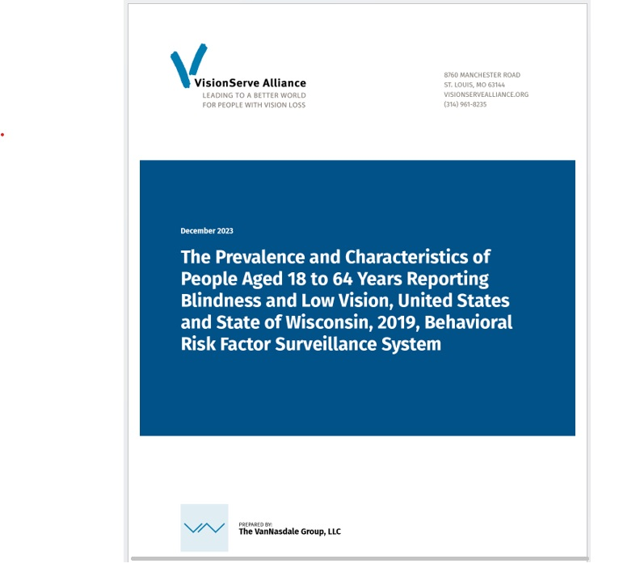

Alt text: Front cover of the Big Data report on working-age adults.

Earlier this year, the VisionServe Alliance (VSA) released reports from the second part of its Big Data Project, focusing on working age adults ages 18 to 64 with blindness and low vision. The report highlights the stark reality of the state of vision loss in Wisconsin, showing that much more needs to be done to enable people of all ages with vision loss to live full, independent lives.

“The power of data like this is that it shows people this isn’t an individual problem. It’s a systemic problem,” Executive Director Denise Jess of the Council says. “It’s not about a lack of character or individual fortitude to overcome challenges. We have structural issues around things like transportation and health equity that diminish people’s quality of life.”

According to the report:

* 91,785 working age adults in Wisconsin report having some form of serious vision loss.
* 48.6% of working age adults with blindness or low vision are currently working, compared to 73.9% of working age adults without vision loss.
* 40.6% of working age adults with vision loss report that they are unable to work, compared to 5.6% of other working age adults.
* 72.5% of working age adults who are blind or have low vision earn less than $35,000 a year, compared to 25% of working age adults without vision loss.

The report goes on to summarize the physical and mental health of working age adults with vision loss.

* 52.7% of working age adults with vision loss report having fair or poor health, compared to 12.8% of working age adults without vision loss.
* 39% of working age adults who are blind or visually impaired report their physical health was “not good” for at least two weeks over the past 30 days, compared to 10% of working age adults without vision loss.
* 48.1% of working age adults with vision loss report their mental health was “not good” for at least two weeks over the past 30 days, compared to 14.1% of other working age adults.
* Working age adults with vision loss who say they are unable to work have significantly higher rates of hearing loss, diabetes, depression, kidney disease and strokes compared to those who are working.

This information presents a spiderweb of interconnected issues that the Council will continue to address through our advocacy. “This is very sobering data, especially when you look at the health outcomes of people who are working versus the health outcomes of those who are unable to work,” Denise says. “We must continue to collaborate with other service providers and lawmakers to get the word out that these are people who want to work but have barriers preventing them from doing so.”

One of the biggest barriers is transportation equity, with accessible options extremely limited in many parts of the state, especially rural areas. In some places, most of the available resources are put toward getting people to medical appointments, with significantly fewer resources available for work, social and shopping-related trips. More funding and greater flexibility for transportation options are badly needed.

Another important issue highlighted in the report is healthcare equity. Most insurers, including Medicare and Medicaid, do not cover critical vision rehabilitation services such as those provided by the Council. While the Council does not turn people away due to inability to pay, that leaves the organization on the hook for the costs of those services. The lack of insurance coverage discourages people with limited income from seeking out these services.

The issue goes beyond physical health. Many mental health providers do not accept Medicaid, meaning someone with vision loss might have to secure transportation to travel over an hour away to see a professional who accepts their insurance. The Council is working hard at both the state and federal levels to expand Medicare and Medicaid eligibility and extend coverage of vision services by these programs.

There is also a severe shortage of vision services professionals in Wisconsin and nationwide, and the professionals who are working tend to be concentrated in major urban areas like Madison and Milwaukee. While the Wisconsin Office for the Blind and Visually Impaired (OBVI) serves the entire state, their staff is stretched thin, and they tend to focus their services on older adults. Consequently, many working-age adults with vision loss, especially those living in rural areas, are unable to access the services they need to live independently and maintain employment.

While allowing vision services to be covered by insurance would certainly help bring more professionals to Wisconsin, the other part of the solution is to expand the pool of who can provide those services. One option would be to encourage occupational therapists (OTs) to receive the necessary specialized training to teach these skills. Because OTs can accept payments from Medicaid, more people would be able to access these services.

Finally, more needs to be done to get people who are blind or low vision into the workforce. The data clearly show that people with vision loss who are working have significantly better health outcomes and quality of life than those who are unable to work.

Denise emphasizes that the information the Big Data Project provides has been a powerful tool in our efforts to create change.

“The point of this data is not to make us feel bad about the state of affairs,” Denise says. “Instead, it shapes how we look at our healthcare and transportation systems. We at the Council can teach people the skills, but without systems change, they will still be sick and still struggle to get where they need to go.”

You can read the full Big Data Report on Working Age Adults at VisionServeAlliance.org/Big-Data-Reports-Working-Age-Adults. You can learn more about all the Council’s advocacy efforts on our website at WCBlind.org/Advocacy.

Header: Support the Council Year-Round by Giving Monthly



Alt text: A person holding a heart shaped sign that says Give Monthly.

Every year, Council donors make annual gifts to help support our mission. Many of our supporters have been doing so for decades. Because these gifts are made once a year, donors sometimes feel they have to give beyond their comfort level to make a real difference.

While we always appreciate that generous support, we understand it can be difficult to make a large gift all at once. Fortunately, there’s an alternative. Rather than making one large donation every year, consider a smaller monthly gift to the Council instead.

Monthly giving is becoming the preferred way to make a gift to the Council. In fact, the number of people giving monthly has increased 11% in the past year alone! That number is growing because giving monthly is an easy, convenient way to support the Council year-round.

Once you’ve set up your bank account to give every month, that amount will be automatically withdrawn, so you can simply factor your gift into your monthly expenses. Giving monthly allows you to help the Council on your own terms based on your budget, and provides the Council with year-round support for the needed services we provide every day.

Your monthly gifts add up over the course of the year. For example, if you give $10 every month, that equals $120 a year. That can help pay for two hour-long access technology classes for someone entering the job market. Giving $20 a month equals $240 a year, which can cover the cost of three orientation and mobility lessons to help someone learn to move safely around their home and community. Giving $35 a month adds up to $420 a year, which can cover the cost of white canes for 12 people. However much you decide to give, you can be confident that you are helping bring important services to people in your community.

It costs the Council a significant amount of money to provide vision services, and clients who have the ability to pay are expected to do so. However, we also know that over 70% of working age adults with vision loss make less than $35,000 a year, putting the cost of vision services out of reach. Gifts to the Council help fill that gap and make an enormous difference in the lives of many of our clients.

If you are not comfortable giving through our website, a staff member at the Council can help you set up your monthly giving. “A Council staff member will call to confirm or help you set up your monthly gift exactly as you want it done,” says Fund Development Director Lori Werbeckes. “We’re reachable and responsive if you need to make a change or if you have any questions.”

Call Lori at 608-237-8114 to set up your monthly gift. You can also indicate that you’d like to set up a monthly gift on the envelope inserted into this Courier newsletter. To give to the Council online, visit WCBlind.org/Donate. Thank you for your support!

Header: Make Your Community Safer During Pedestrian Safety Month

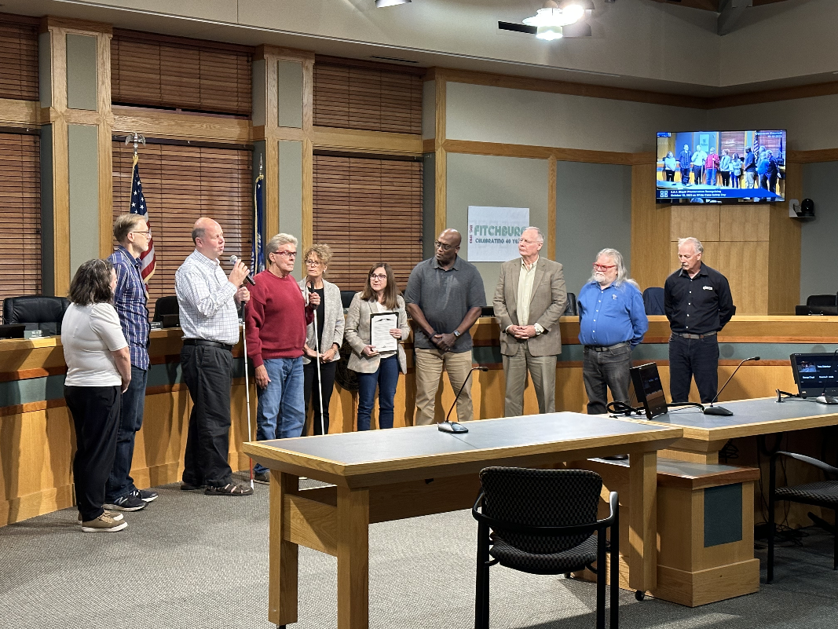

Caption: The Council’s Jim Denham accepting a White Cane Safety Day proclamation by the Fitchburg City Council.

Alt text: Jim Denham speaking into a microphone while standing with nine other people in front of a Fitchburg City Council meeting.

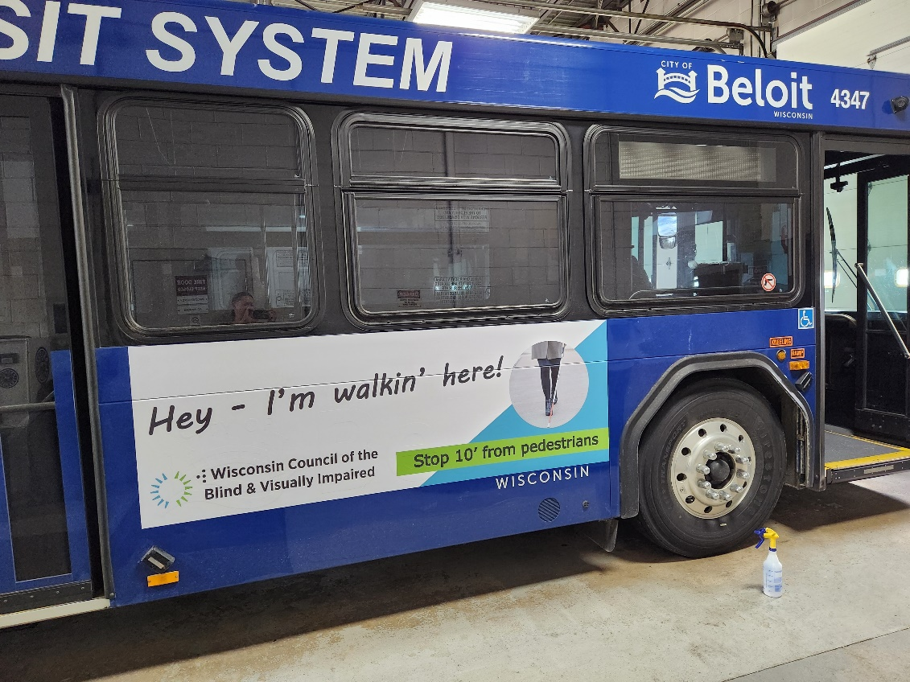

Caption: This year, the Council placed ads on buses in four Wisconsin communities: Beloit, Janesville, La Crosse and Waukesha.

Alt text: An ad on the side of a Beloit bus reading Hey, I'm walkin' here.

October 15 is White Cane Safety Day, an opportunity to spread the word about each state’s White Cane Law. It’s no coincidence that this observance takes place during Pedestrian Safety Month, celebrated throughout October each year.

“White Cane Safety Day really took off after a rise in pedestrian-car accidents during the pandemic,” says Executive Director Denise Jess of the Council. “Pedestrian travel is a very important and valid form of transportation. It’s not just going out for a walk. It’s a vital way to get around, and it must be done in environments that are safe.”

Thirty-one percent of people in Wisconsin are nondrivers. That includes people who are blind and low vision as well as seniors and people who simply choose not to drive. But it’s important to recognize that everyone, including people who do drive, is a pedestrian at some point, and everyone deserves to be safe when walking through their community. While [the number of pedestrians](https://www.wpr.org/transportation/pedestrian-deaths-decreased-2023-wisconsin#:~:text=Pedestrian%20deaths%20fell%20in%202023,the%20Governors%20Highway%20Safety%20Association.) killed by vehicles dropped slightly in 2023, even one death is too many and action needs to be taken to make our streets safer for all.

The Council works on pedestrian safety issues at both the state and federal levels, but some of the most impactful change happens right in your own backyard. By advocating with local leaders, you can make a difference in your community and help make it safer for everyone to get to where they need to go.

The first step in making your community more pedestrian-friendly is identifying the problems and trouble spots. For example, maybe your neighborhood doesn’t have sidewalks, forcing you to walk in the road. Or maybe there are inadequate crosswalks across a busy road. One great resource in helping you identify issues in your neighborhood is the [AARP Walk Audit Tool Kit](https://www.aarp.org/livable-communities/getting-around/aarp-walk-audit-tool-kit-download/). In addition to helping you notice problems, the tool kit includes a glossary of terms for different streetscape features to help you better understand what changes to ask for.

After you’ve identified the issue, you then have to figure out who owns the road that needs to be addressed. For example, your local city government can’t do much about a problem on a county-owned road. Your local or county transportation office can tell you who owns what road and can help you determine whom you need to talk to in order to get action. Once you know where to direct your advocacy, you could consider taking those officials on a walk audit of the area to show them in person what needs to be done.

Your advocacy will be more powerful if you can describe how the problem affects a wide range of people. An issue that impacts someone who is blind or low vision and needs to walk to work is probably also a concern for an older adult walking to their pharmacy and a family walking to a nearby park playground. When outlining your issue to local leaders, start by explaining how the issue affects you personally, then broaden it to describe how it impacts everyone in the community.

“I often see people who are new to advocacy go to local officials and tell their story, which is great, but they don’t connect the issue to everyone else who struggles with it, and they get written off,” Denise says. “Casting a wide net is so important.”

For years, the Council has been working with municipal leaders across the state to proclaim October 15 White Cane Safety Day. These proclamations affirm their commitment to making their communities safe and accessible for everyone. But White Cane Day is only one piece of the larger movement to make communities safe for all pedestrians. The most effective way to contribute to that change in your community is to become an advocate yourself.

You can find more information on pedestrian safety and White Cane Safety Day on our website at https://wcblind.org/events/white-cane-safety-day and https://wcblind.org/wp-content/uploads/2023/08/WCBVI-Pedestrian-Safety-2023.pdf.

The Council is also preparing to launch a new advocacy discussion group later this year to regularly discuss effective advocacy strategies. Watch our website, our On Sight e-newsletter and our social media for more information in the coming weeks.

Header: Change to IRA Distribution Rule Doesn’t Affect Your Ability to Support the Council

Starting in 2023, the SECURE 2.0 Act raised the age that you must begin taking required minimum distributions (RMD) from your IRA and qualified employer sponsored retirement plans to age 73. That change, however, does not affect the age at which you can make tax-free gifts to charities from those plans.

Gifts to support the Council or other charitable organizations can be made tax-free from your IRA or employer sponsored plan beginning at age 70½. The maximum amount that can be donated is $100,000. A gift to a qualifying charity will count toward your RMD in the year the gift is given.

More and more, donors in their 70s and 80s are using this tax-saving opportunity when making gifts to the Council. “It’s an opportunity to support the Council’s work, contribute to your required minimum distribution, and enjoy tax savings,” says Fund Development Director Lori Werbeckes. “With the help of your plan advisor, a gift from your IRA is practical for you and vital for sustaining Council services for the growing number of people in Wisconsin living with blindness and low vision.”

If a gift from your IRA is a good fit for you, talk with your financial advisor to get started.

Header: Upcoming Events

Pedestrian Safety Month/White Cane Safety Day

Throughout October, we celebrate Pedestrian Safety Month, an opportunity to promote the many measures communities can adopt to become safer and more welcoming to those who get around on foot. White Cane Safety Day, October 15, is an opportunity to raise awareness of White Cane laws that require drivers to stop for pedestrians using a white cane or guide dog.

Gallery Night

Our annual Gallery Night event showcases the work of artists with vision loss from around Wisconsin. This year’s event takes place Friday, November 1.

Header: Fall 2024 Sharper Vision Store Featured Items

**Wilson Digital Recorder**

The Wilson™ Recorder is a simple-to-use digital recorder that can store up to 12 hours of recordings based on the selected recording quality. The buttons are on the front of the recorder. #CR430

$60.00

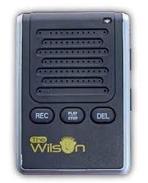

**Talking Tile**

Record and play back 80 seconds using the built-in microphone and speaker. Re-record and re-use as many times as you wish. The large size and robust housing is ideal for those with visual impairments. #CR465

$20.00



**PENfriend 3 Audio Labeler**

The PENfriend 3 creates audio labels for any item on which a sticker label is applied. It can record 125 hours, has 4GB of memory, and has high contrast yellow buttons. Recording is easy with a simple on/off mechanism. It comes with 127 colored labels and 10 magnetic badges that are perfect for labeling canned goods, making notes or lists, or marking food items. #HL670

$165.00

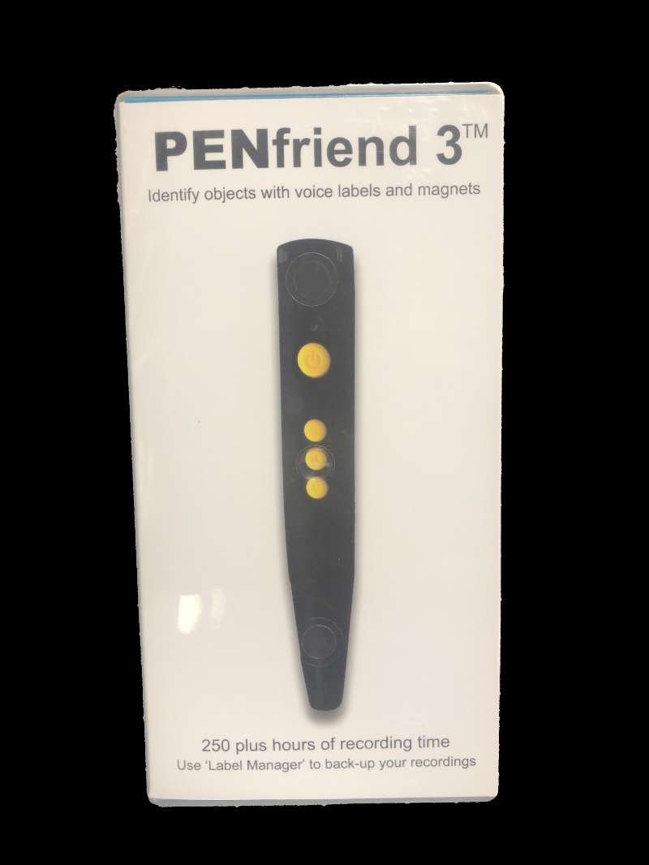

**3M Labeler with Braille Dial**

This braille labeler is perfect for organizing belongings. This labeler has a tactile dial with both braille and print letters. The dial has the complete alphabet, as well as number signs, commonly used contractions, and punctuation marks. #HL150

$44.00



**Signature Guide**

This signature guide is made of durable plastic and is sized to fit a standard signature area. It measures 3-3/8 by 2-1/8 inches. #WG616

$1.00

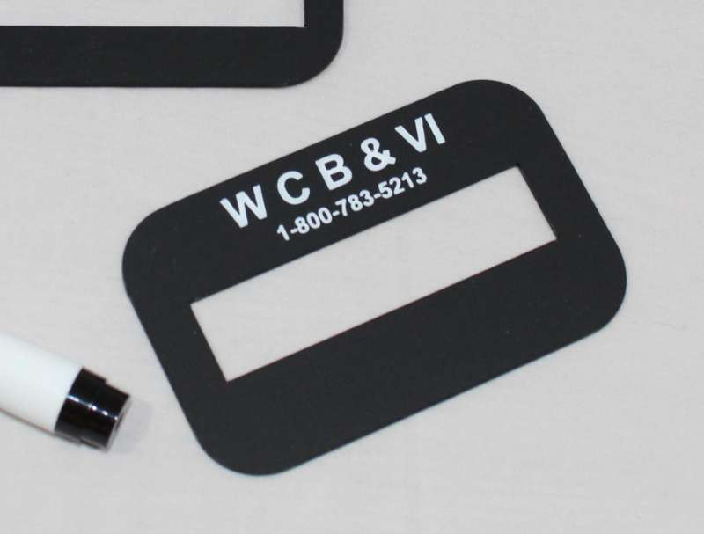

**Flip Check Guide**

This hinged check writing guide fits a standard checkbook size check, measuring 2.75” x 6”. The hinge makes holding your check in place easier while filling out all the sections, which users will appreciate. #WG425

$7.00



**Letter Guide**

This writing guide is made of durable plastic with 13 openings. This guide measures 8-1/2 x 11 inches and fits standard line spacing. #WG103

$4.00



**Envelope Writing Guide**

This durable plastic envelope guide fits on top of standard #10 business envelopes. It is black, providing high contrast. #WG201

$3.00



**Sharpie Bold Pen**

The Sharpie Pen can mark on just about any material (glass, metal, wood, plastic, paper, glossy labels, photographs). It produces a bold, black line that is water resistant and quick-drying. Not recommended for letter writing. #WG703

$1.75

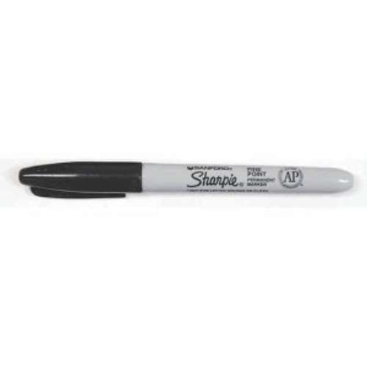

**20/20 Pen BOLD**

This pen writes in dark black lines that are 1 millimeter wide. The ink does not bleed through the paper and dries quickly. #WG728

$1.75

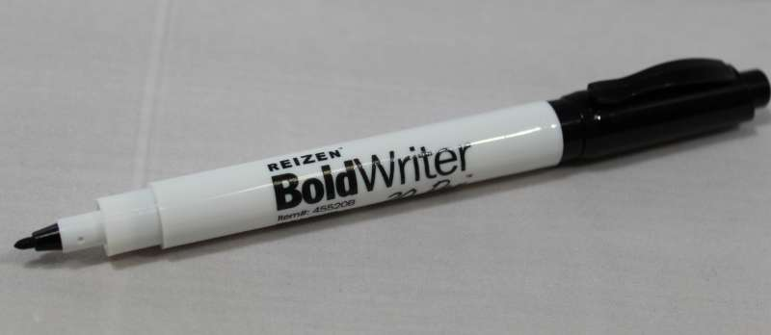

**20/20 Slimline Pen**

Writes lines in dark black that are 1 mm wide. Ink dries quickly and does not bleed through the paper. #WG700

$1.75

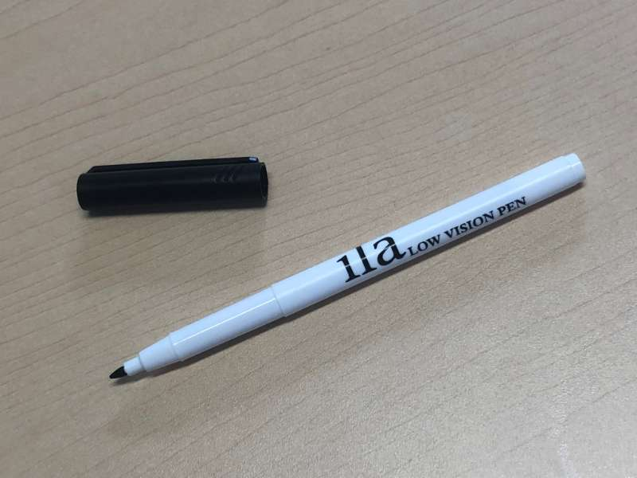

**Big Print Address Book**

The lines of this big print address book are spaced 1/2 inch apart to provide ample room for large handwriting and easy reading. This book contains three name listings per page and over 500 total individual listing spaces. Measures 7-1/2 x 9-1/2 inches with spiral binding and alphabetical tabs. #WG307

$22.00

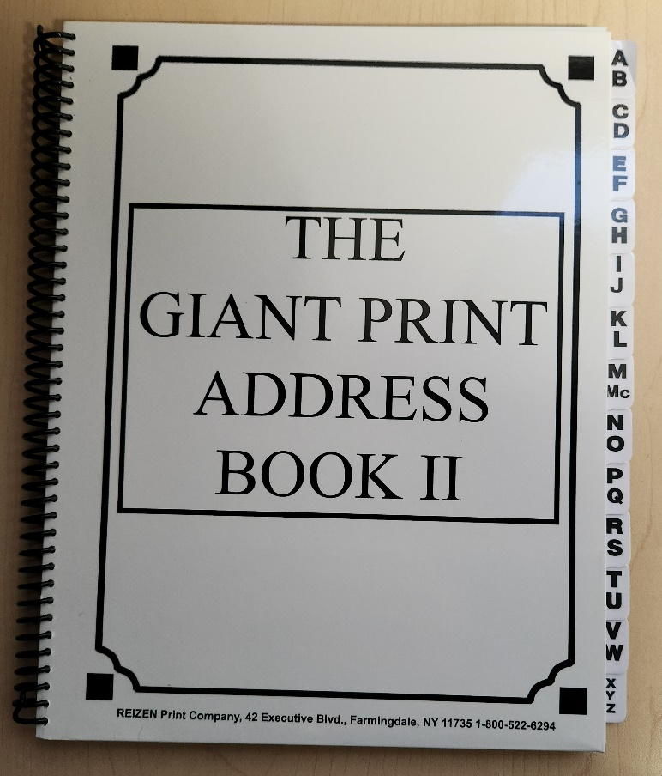

**Large Print Check and Deposit Register**

Use this large, easy-to-see check and deposit register to maintain a record of all your check transactions. Each 8 x 11 page is designed for 12 entries. 50 pages provide space for a total of 600 entries in the register. #WG505

$9.50



**Bold Lined Paper Yellow**

This is a yellow pad with 11/16-inch tall bold lines across and no vertical margins. It is 8.5-by-11 inches. The pad contains 100 sheets and is extra-wide ruled. #WP140

$8.00



**3/4" Bold Line Notebook**

This notebook has 70 sheets with thick black lines that are ¾ of an inch apart and printed on both sides. It measures 8.5 in. x 11 in. #WP150

$8.00

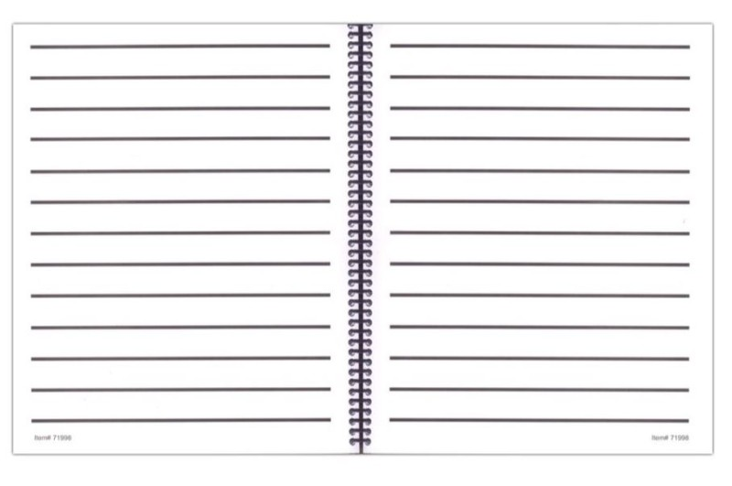

Back Cover:

Did you know that the Council Courier is also available in braille and audio formats? To request an alternative format or update your mailing address, call us at 608-255-1166.

The Council also publishes weekly e-newsletters that include features, helpful tips, advocacy information, upcoming events and more. You can subscribe at **WCBlind.org/newsletter-signup**.

**Contact Us**

Wisconsin Council of the Blind & Visually Impaired   
754 Williamson Street, Madison, WI 53703   
608-255-1166  
800-783-5213  
WCBlind.org  
info@WCBlind.org