Council Courier, Winter 2025

Making Progress and Breaking Barriers: 2024 in Review

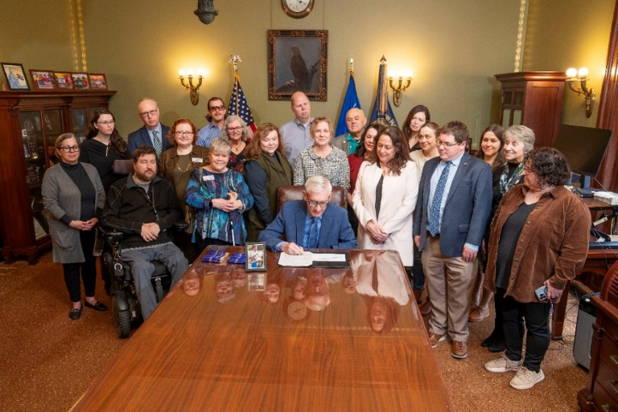

Caption: Gov. Tony Evers signing Steve’s Law into the state statutes.

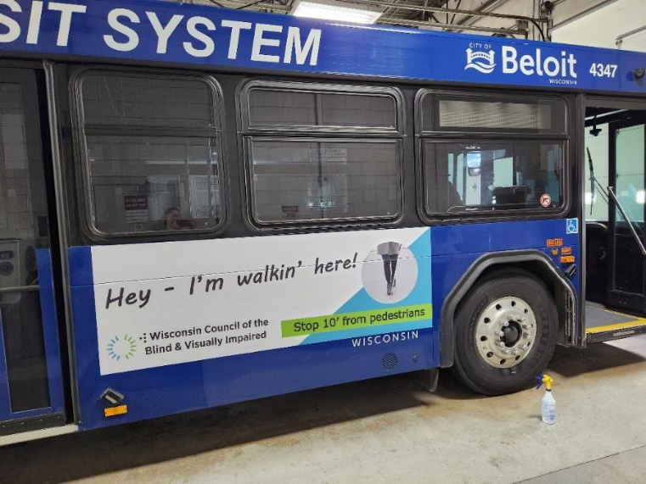

Caption: Our Pedestrian Safety Month ad on the side of a Beloit bus.

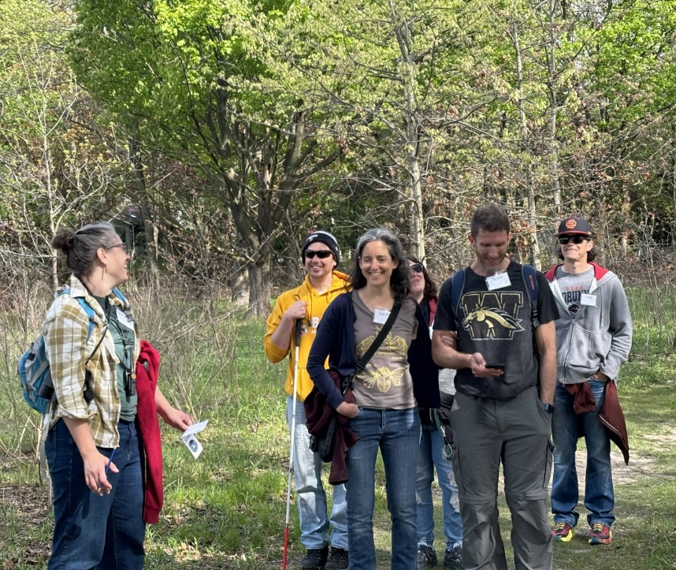

Caption: Birding by Ear

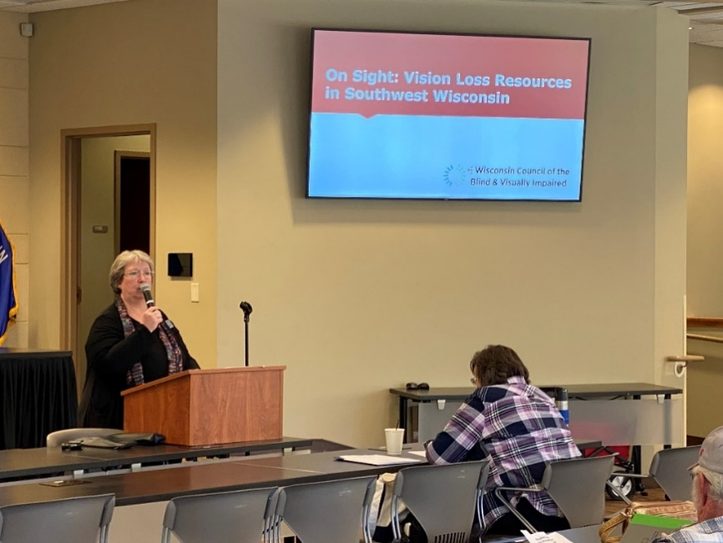

Caption: Amy Wurf presenting at our On Sight event in Dodgeville.

2024 is in the books, and it was another great year for the Council. “2024 was a full and dynamic year across all three of our pillars: advocacy, education and vision services,” says Executive Director Denise Jess. “The combined efforts of Council staff and board, the support of our donors and volunteers, and our collaborations with many partner organizations around the state have laid the foundation for these successes, now and into the future.”

We started the year with a strong advocacy win, as Governor Evers signed into law 2023 Wisconsin Act 114, otherwise known as “Steve’s Law.” Named in tribute to Steve Johnson, an avid outdoorsperson and former member of the Council’s Board of Directors, the law allows people to use a State ID to prove their state residency when purchasing things like fishing and hunting permits through the Department of Natural Resources’ online Go Wild system. The Council had been working with state lawmakers for years to pass Steve’s Law, and while there is still work to be done to allow the use of State IDs in place of a driver’s license in all areas of government, Steve’s Law marks a major stepping stone toward that goal.

It was a busy spring, with three great educational events taking place in May. We held our Advocacy Day event to help people across the state gain the tools to work with local leaders on the issues that matter to them. Birding by Ear saw us join forces with the Southern Wisconsin Bird Alliance (formerly Madison Audubon) and new partner Aldo Leopold Nature Center to show how sound can be just as important in birding as sight. And we returned to Brix Cider in Mount Horeb for Dining in the Dark, where diners donned blindfolds to experience a three-course meal focusing on senses other than vision.

In June, we continued our decades-long tradition of awarding scholarships to students who are blind or low vision from across the state. 2024 saw six students receive $2,000 scholarships to further their education in a variety of fields. Whether they were incoming freshmen, graduating seniors, or even PhD students, all our 2024 Council Scholarship recipients continued to break down barriers and pursue higher education in fields of their choosing.

Over the summer, we gained a powerful new advocacy tool in the VisionServe Alliance’s (VSA) Big Data Report on Working Age Adults. This second in a series of VSA Big Data reports confirmed what the Council has long known: Vision loss is more prevalent in Wisconsin than most people realize, and available vision services are not meeting the level of need. While the data is sobering, the information contained within the report is monumental in supporting our advocacy for systemic changes in our healthcare and transportation systems to promote employment success and overall well-being.

In October, several staff members travelled to Dodgeville for a new event, On Sight: Vision Loss Resources in Southwest Wisconsin. Alongside the Aging and Disability Resource Center (ADRC) of Southwest Wisconsin, the Wisconsin Talking Book and Braille Library, and Rehabilitation Specialist Chasie Willis of the Wisconsin Office for the Blind and Visually Impaired, our On Sight event helped introduce people to the vision services available to them and helped affirm that people who are blind or low vision living in rural areas can live independently on their own terms with the right knowledge and support. We’re grateful to the generous local foundation that funded this event.

October was also Pedestrian Safety Month, which includes White Cane Safety Day on October 15. Over three dozen municipalities across the entire state issued White Cane Safety Day proclamations this year, along with the State of Wisconsin and Milwaukee County. Local advocates in all corners of Wisconsin continued to work tirelessly to make their communities safer by working with local leaders to improve pedestrian safety infrastructure throughout their neighborhoods and communities.

In November, we once again opened our doors to the community for our annual Gallery Night event. In 2024 we featured the work of nine artists from across the state who are blind or low vision. Turnout was great, and the art on display delighted and inspired everyone who came through our doors.

We are grateful to the many individuals, service organizations, grantors and businesses who contribute financially to the Council throughout the year. Those gifts enable us to provide services for every client regardless of their ability to pay, and their sponsorship enables us to present excellent events, like Gallery Night. Thank you to everyone who supported us in 2024, and to everyone who will continue to support us for the years ahead.

Header: Letter from Executive Director Denise Jess

Subhead: New Strategic Goals in Pursuit of Our Ongoing Mission

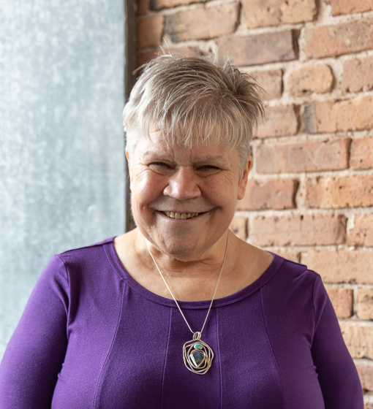

Every three years, the Council develops new strategic goals. Nonprofits use strategic plans to advance our missions, to respond to current community needs and trends, and to innovate. This is the third strategic plan in my tenure as executive director here at the Council. Each plan has helped us move the needle to promote the dignity, independence and empowerment of Wisconsinites who are blind or have low vision. I’m looking forward to our new plan’s launch in January 2025 to see where it leads us.

A major theme throughout our three-year plan is collaboration and partnerships. While the Council provides invaluable leadership in the state, we know that by working with others, our efforts are strengthened and broadened. Our relationships with other nonprofits, service providers, state agencies, legislative partners and the broader community enhance our advocacy efforts in transportation access, vision services provision and other civil rights.

Another theme is financial well-being. As the number of people experiencing vision loss continues to grow rapidly, the cost of providing vision services, education and advocacy to reduce barriers and enhance quality of life grows with it. Our strategic plan guides us to develop robust and sustainable funding sources that carry us well into the future.

We know that blindness and vision loss touch all aspects of our society, across geography, socioeconomic class, education level, race, ethnicity, preferred language, gender identity and sexual orientation. Woven throughout the plan is a commitment to connect with and serve diverse communities with integrity and dignity.

Finally, the plan speaks to the importance of supporting staff in this work to maintain a healthy work environment where people are compensated fairly for their talent, where people want to grow professionally and personally, and where we can attract motivated and talented individuals to fill open positions when they occur.

Over this year, you can watch the plan unfold by reading both the Courier and our weekly “On Sight” e-newsletter; checking us out on social media; joining us for an in-person or virtual event; attending an access technology class; reaching out for vision services; or joining our newly formed advocacy discussion group. We hope our paths will cross many times this coming year.

Header: A Warm Welcome to Our Four New Board Members

As we begin 2025, we are pleased to welcome four new members to the Council’s Board of Directors. Each of our new board members brings unique experiences and backgrounds that will help the Council reach people across Wisconsin who are blind or low vision.

“The Board is pleased to welcome our four new members,” says Board Member Chip Kaufman, who chairs the Nominating Committee. “Not only is this a larger incoming class, but one of our more diverse. We are excited to have their unique experiences and voices added to our Board, and we will all benefit greatly from working with them. It is a very exciting time to be working with the Council and moving our mission forward.”



Caption: Elizabeth Fryseth

Elizabeth Fryseth of La Crosse brings years of experience in local advocacy work to the Board. Elizabeth has worked tirelessly with local officials on issues that include pedestrian safety, guide dog awareness, and personal safety. Her strong commitment to advocacy makes Elizabeth a great fit for our Board in supporting the hard work that lies ahead.

Elizabeth has served on multiple boards and committees operating in western Wisconsin, including the La Crosse Area Transit Advocates, the Disability Action Network, the Independent Living Resources Board and her local Lions Club. In 2023 she was awarded the La Crosse YWCA Outstanding Woman Award for Social Justice.



Caption: Mikyla Mobley

Madison resident Mikyla Mobley has worked with both Madison’s city government and the Wisconsin Department of Workforce Development’s Division of Vocational Rehabilitation. A recent graduate of Edgewood College and former Council Scholarship recipient, Mikyla’s strong skills as an organizer make her a great fit for our Board. Mikyla helped start Madison West High School’s first Black Student Union and spent several years in leadership roles with Edgewood College’s Black Student Union.

Mikyla says her biggest motivation in her advocacy is helping people of color and people with disabilities. In her work with the Edgewood Black Student Union, she was able to build coalitions with other campus organizations to create unity and support across many different communities. Mikyla says she hopes to continue the work of reaching out to different communities in her role as a Council Board member, and we are excited to bring her experience into our ranks.



Caption: Sanbrita Mondal

Sanbrita Mondal of Middleton is Chief of Vision Rehabilitation Services at UW Health in Madison, where she also works as a low vision optometrist. Sanbrita helped establish the first formal low vision clinic at UW Health in 2016, and has a strong, longstanding professional commitment to empowering people with vision loss in Wisconsin.

Sanbrita is also an adjunct associate professor and research scientist at UW-Madison, where she trains the next generation of ophthalmologists in the importance of vision rehabilitation services. Sanbrita’s passion to grow the world of vision services in Wisconsin makes her a valuable addition to our board.



Caption: Nycole Torres

Nycole Torres of Menomonee Falls brings a strong advocacy background to the Board through her work with the League of Women Voters of Wisconsin. As the League’s Diversity, Equity and Inclusion Manager, Nycole works every day to make sure everyone’s voice can be heard.

The new year also brought the end of several board members’ terms. We would like to thank all our outgoing board members for their tireless work. Thank you to Rhonda Staats, Sharon Knauf, Patty Slaby, Rebecca Arrowood, Chamomile Harrison and Nat Tarnoff for their efforts in support of the Council’s mission!

Header: Giving in 2024

We’re grateful for 207 NEW donors who supported the Council in 2024.

Gifts ranged from a 12¢ round-up on a store purchase to bequests over $250,000. Each gift is valued and appreciated.

63% of donors give consistently. Many have been giving for 40 years or more!

40 monthly donors in the White Cane Circle. As we approach the Council’s 75th anniversary, help us secure 75 monthly donors!

Header: Support the Council for Years to Come Through Planned Giving



Many of us have an organization that has made a substantial difference in our lives. We cherish those important groups and want them to continue to thrive after we are gone. Planned giving enables you to establish your legacy and make a long-term impact on a cause that matters to you.

One of the most popular ways to participate in planned giving is by making a bequest to the Council through a will or trust. Arranging for a bequest is one of the easiest forms of planned giving, and perhaps one of the most meaningful as well. The Council is deeply honored whenever we are the beneficiary of a bequest, and those who name the Council in their will know that the money will be used to support the hundreds of people who come to the Council every year for the vision services and other help we provide.

Here is the suggested wording for including the Council in your will: “I give, devise, and bequeath to the Wisconsin Council of the Blind & Visually Impaired, Madison, Wisconsin, (insert dollar amount or percentage of the residue of your estate) to be used for the Council’s general purposes.”

Another way to participate in planned giving is to name the Council as a beneficiary of a life insurance policy. If your family’s financial well-being is already accounted for, naming the Council as a beneficiary can have an important impact in the years to come. Planned giving can also come through an IRA charitable distribution. This method is increasingly popular for donors older than 70, as the dollars given are not taxed.

Barbara Nilsson has given financial gifts to the Council for nearly a decade, and this year moved to giving through her IRA. She started giving after her father lost his vision and began receiving services from the Council. In addition to vision rehabilitation therapy sessions in his home, the Council also signed him up for the Wisconsin Talking Book and Braille Library. “He was an avid reader and really missed that,” Barbara says. “With the talking books, he got a little bit of his life back.”

When reviewing her IRA required distributions and making decisions on which organizations to make contributions to, the Council was at the top of her list. “I don’t donate to many organizations, but I am so appreciative of the services that the Council provides,” Barbara says. “The work the Council does is invaluable.”

For more information on making a planned gift, contact Fund Development Director Lori Werbeckes at [LWerbeckes@WCBlind.org](mailto:LWerbeckes@WCBlind.org) or 608-237-8114. And as always, you can make an immediate donation to the Council on our website at [WCBlind.org/Donate](https://wcblind.org/donate/).

Header: Front Desk Staffing Changes Bring Goodbyes and Hellos



Caption: Judith Rasmussen

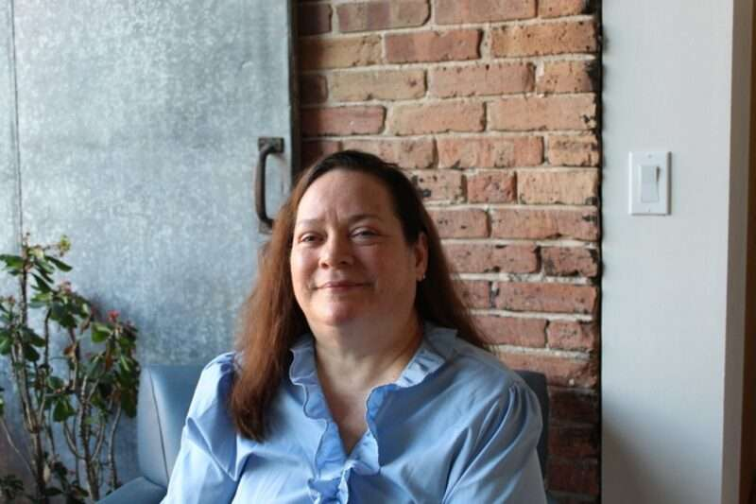

Caption: Susan Bosques

First impressions are often the most important, and that couldn’t be more true at the Council. When people call the Council for the first time or walk through the front doors of our Madison offices, they might be new to blindness or low vision and unsure what steps they need to take to continue living their lives with dignity and independence. Thanks to our caring and informative front desk staff, those anxieties can start to ease as they begin to learn that losing your vision is a journey, not an end.

Our front desk saw some change in 2024 as long-time Administrative Assistant Judith Rasmussen left the Council to begin her next stage in life and new Administrative Assistant Susan Bosques joined our team. We’re extremely grateful to Judith for her 16 wonderful years at the Council, and we extend a hearty welcome to Susan.

Judith started working at the Council in 2008 after hearing about the job opening from a friend. After a single interview, Judith was hired on the spot to work at our front desk and produce braille copies of our Council Courier newsletter, Annual Report, and other important documents. Judith has also represented the Council on the Latino Health Council in Madison, and took on an educational role by visiting Dane County elementary schools to teach children about braille.

But what Judith will remember most are the calls that come in every day. “I’ve known some people for years before they first reached out to the Council,” Judith says. “It’s a pleasure to hear them on the other end and to help them. And sometimes I meet new people for the first time and watch them come back and grow over time.”

“I’m so grateful for everything Judith has brought to her work at the Council, from the kindness and warmth extended to our visitors and callers to her genuine curiosity and love of learning to her joyous laugh and her appreciation and respect for all of her colleagues,” says Executive Director Denise Jess. “We will miss you, Judith, and wish you all the best in the next phase of your life’s journey.”

Susan Bosques began as the newest member of the Council staff in September of 2024, joining the crew as an Administrative Assistant. Susan comes to the Council after many years traveling the globe and working as a tech analyst. Her work has taken her everywhere from Spain to Tennessee and even to cruise ships on the ocean. “I like to say I’ve worked with everything from planes to trains to automobiles!” Susan says.

After losing her vision later in life, Susan began coming to the Council as a Vision Services client. When she heard that we were hiring, she thought it would be the perfect opportunity to get back into the workforce. Welcome to the team, Susan!

Council Scholarships Have Been Stoking Opportunity for Decades



Caption: Annika Konrad

For much of our history, the Council has given scholarships to students in Wisconsin who are blind or low vision to help them continue their education past high school. Students with vision loss often take on a variety of additional expenses when attending school, such as adaptive devices. And in addition to the usual costs of schooling like tuition, books and housing, transportation barriers force many students to use more expensive alternatives to get around. Thanks to Council scholarships, recipients can spend fewer hours working in a part-time job to afford these extra costs and devote more time to being successful in the classroom.

“Educational attainment is a critical tool for reducing barriers to employment for people who are blind or low vision,” says Council Executive Director Denise Jess. “The Council is grateful for the opportunity to support students in reaching their education goals through our scholarship program. We recognize that our students experience unique costs that most other students do not face. Our scholarships help compensate for those additional expenses.”

As part of our mission to promote the dignity and empowerment of people who are blind or low vision across Wisconsin, we encourage all students with vision loss to seek further education past high school. As the VisionServe Alliance’s Big Data Report on Working Age Adults shows, access to well-paying jobs is a key to physical, mental and financial well-being for people with vision loss. Yet only around 7% of working age people with vision loss have graduated college, compared to nearly 30% of people without vision loss. The goal of the Council’s scholarship program is to help close that gap and help young people with vision loss achieve whatever they put their minds to.

Part of the reason we continue to provide scholarships is that we know many recipients will use their education to give back to the blind and low vision community. Former recipient Annika Konrad graduated from UW - Madison with a PhD in English in 2018. During her time in Madison, Annika not only excelled in her studies, but found time to give voice to the blind and low vision community in Madison by starting a community writing project. Eventually titled “The Outlook from Here,” the project allowed people with vision loss to share their stories about everyday life.

Annika became more involved with the Council through her writing project, eventually serving on our Board of Directors for several years. “The community writing project allowed me to really work with the Council and let me think about the different stories we tell about disability,” Annika says. “It made me think about how we can use those stories to make change in our community.”

Now the Associate Director of the University of Michigan’s English Department Writing Program, Annika has used her knowledge to continue educating the general public about the lives of people with disabilities. Annika’s work illustrates how Council scholarships help not only the recipients themselves, but also the lives of everyone who is connected to the vision loss community.

The application period for 2025 Council Scholarships opens in January 31, with completed applications due March 21. For more information, visit https://wcblind.org/events/scholarships.

Header: New Advocacy Discussion Group Offers Space for Learning, Support and Action



For several years, the Council has hosted regular online low vision support groups to connect people who are blind or low vision across the state. At the beginning of 2025, the Council started a new kind of group where people with vision loss can connect and share ideas and resources for their advocacy efforts.

Policy advocacy was the very reason for the Council’s creation over 70 years ago, and it remains one of our core functions today. The new Advocacy Discussion Group is a space for learning, support and action, where local advocates from across Wisconsin can share their own triumphs and roadblocks. We see this new group as a next step in building a statewide network of motivated people equipped to engage with local and state decision-makers in productive conversations about the issues they care about.

“Advocacy has been a pillar of the Council since our founding in 1952,” says Executive Director Denise Jess. “It is powerful when constituents reach out to their elected officials to tell our stories and advocate for what we need to live full and vibrant lives. The advocacy discussion group is an exciting new tool for the Council to support the voices of advocates around the state.”

Each meeting will include both a short presentation by Council staff on a relevant advocacy topic, such as legislative updates and advocacy skill-building; and opportunities for participants to exchange insights, ask questions and share information about their own advocacy efforts.

The group meets on the third Wednesday of alternating months from 3:00 to 4:30 p.m. If you are interested in making a difference in your community, we hope you will consider taking this opportunity to grow your voice as an advocate and to help others grow as well.

To sign up for this group, visit our website at [WCBlind.org/Council-Events/Advocacy-Discussion-Group](https://wcblind.org/council-events/advocacy-discussion-group/), or contact us at 608-255-1166 or at AdvocacyGroup@WCBlind.org.

Header: Winter 2025 Sharper Vision Store Featured Items

Winter Courier 2025 Featured Store Items

Settle in for a Sunday meal with these kitchen items!

**PalmPeeler**

Protect your fingers while you effortlessly peel fruits and veggies in seconds with this fun and simple design. The PalmPeeler features an ergonomic shape and stainless-steel loop eyer for more efficient vegetable peeling. #HK650

$12.50

**High Contrast Cutting Board**

This cutting board measures 15-3/4 x 10 inches. It is white on one side and black on the other allowing you to find the best contrast for your cutting needs. For example, you can place carrots on the white side and onions on the black side. Item # HK450

$22.00

**Knife with Adjustable Slicing Guide**

The DeliPRO knife is an adjustable kitchen knife that cuts perfect, uniform slices every time. Its built-in adjustable slice guide can be set between 1/4 to 1 inch. The included safety fork allows you to hold the food steady during cutting, keeping your fingers away from the blade. Cutting board and finger guard in picture are sold separately. Item # HK110

$22.00

**Finger Guard**

Protect your fingers while using a sharp knife for cutting with this DigiGuard finger protector. To use it, just slide it over your first and third fingers. It can be used by either right- or left-handed people. Item # HK1010

$8.50

**Talking Timer**

The talking countdown timer speaks the hours and minutes during setting and can be set up to 24 hours. Remaining time is spoken in hours, minutes and seconds on demand with the press of a button. Item # HT160

$16.50

**Low Vision Timer**

This tactile large print timer features raised bold black markings on a white background for high contrast and visibility. This sixty minute timer is free standing for extra convenience in your kitchen. Item # HT108

$22.00

**Braille Long Ring Timer**

A standard, long-ring timer with one tactile dot at every 2-1/2 minutes and three dots at 0, 15, 30 and 45 minutes. Item measures 3 inches wide by 3-1/2 inches tall. Item # HT130

$20.00

**Push Pull Oven Ruler**

The Push Pull Oven Ruler allows you to safely pull out your oven rack without getting your hands near the hot oven. A magnet on the back allows for easy storage on your fridge. Item # HK575

$4.00

**Measuring Cups (White)**

This set of four white measuring cups has high contrast measurement markings for easy identification. Blue markings on the handle and bottom of the cup identify the volume. Standard measuring cups sizes in quarter, third, half and one cup. Item # HK433

$8.50

**Measuring Spoons (White)**

Set of six white measuring spoons with blue markings. The high contrast measuring spoons set includes 1/8, 1/4, 1/2 and 1 teaspoon, and 1/2 and 1 tablespoon. Molded lettering won’t wear off over time. Item # HK413

$4.50

**Visual Measuring Cups**

The Visual Measuring Cups all nest neatly inside of each other for convenient storage. This inclusive design helps everyone tell at a glance or feel what the measurement is. These clear plastic kitchen tools are dishwasher-safe, made of high-quality BPA-free material. SET INCLUDES 1/4 cup, 1/3 cup, 1/2 cup and 1 cup. Item # HK414

$30.00

**Visual Measuring Spoons**

The Visual Measuring Spoons all nest neatly inside of each other for convenient storage. This inclusive design helps everyone tell at a glance or feel what the measurement is. These clear plastic kitchen tools are dishwasher-safe, made of high-quality BPA-free material. SET INCLUDES 1 Tablespoon, 1 teaspoon, half teaspoon, and ¼ teaspoon, joined by a removable loop. Item # HK415

$28.00

**Oven Mitt**

This 17-inch long oven mitt covers most of your arm, reducing the risk of burning yourself in the kitchen. This oven mitt is flame retardant and can withstand temperatures up to 400 degrees F. Item # HK170

$5.00

**Talking Kitchen Scale Vox 3000**

This stylish talking kitchen scale uses strain gauge technology for extreme accuracy and precision. Results are announced in ounces or grams with a max capacity of 6.6 pounds. The spoken voice can be turned off and the scale can be operated with or without the removable bowl. Item # HK710

$44.00

**Liquid Level Indicator**

A sturdy design easily determines when a container of liquid is filled to within approximately one inch of the top. Hang this popular unit over the lip of a container. When liquid reaches height, a buzzer will sound and unit will vibrate. Item # HK500

$14.00

**Double Spatula Turner**

This nylon coated double spatula makes gripping and flipping your food a breeze. Just slip one side under your hamburger, squeeze down with the other, and flip. Cooking is easier and less messy, leaving you more time to socialize with guests. Item # HK305

$13.50

Back Cover:

Did you know that the Council Courier is also available in braille and audio formats? To request an alternative format or update your mailing address, call us at 608-255-1166.

The Council also publishes weekly e-newsletters that include features, helpful tips, advocacy information, upcoming events and more. You can subscribe at **WCBlind.org/newsletter-signup**.

**Contact Us**

Wisconsin Council of the Blind & Visually Impaired   
754 Williamson Street, Madison, WI 53703   
608-255-1166  
800-783-5213  
WCBlind.org  
info@WCBlind.org