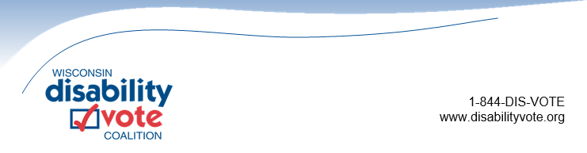

**Supporting Safe, Secure, and Accessible Voting for All**

According to the Center for Disease Control, approximately 26% of American adults have some type of disabling condition and may experience disability-related barriers to registering to vote and casting a ballot. This can include inaccessible polling places, limited access to transportation, and lack of acceptable photo ID for voting as many are non-drivers. The Wisconsin Disability Vote Coalition (WDVC) puts forward the following recommendations for the 2025-27 Wisconsin State Budget to help ensure people with disabilities can fully participate in the electoral process by addressing these barriers.

1. Allocate additional funding to the Wisconsin Elections Commission (WEC) for expansion of their Accessibility Review and Supply Program, which would support additional polling place accessibility reviews conducted on election days and the Accessibility Supply Program which provides cost-effective and simple solutions to address accessibility issues at polling places. WDVC supports WEC’s requested increase of 20 percent for this program.

2. Allocate additional funding to the Wisconsin Department of Transportation for specialized transportation programs (Wis. Stat. §85.21 and §85.215) to fund transportation for voting related activities including transportation to the DMV, municipal clerks, early voting locations, and to polling sites on election day.

3. Increase DMV access to meet the needs of non-drivers including people with disabilities and older adults who need photo ID for voting, including:

a. Funding to increase service hours at existing DMV locations to include expanded weekday hours and Saturday hours in the four weeks preceding a statewide election.

b. Funding to implement co-location of DMV state ID operations or mobile DMV sites at locations that are already accessed by people with disabilities and older adults such as Aging and Disability Resource Centers, income maintenance offices, and human service departments.

4. Allocate funding to support development and implementation of an accessible absentee ballot. While a final ruling has not been made in the current litigation regarding the implementation of an accessible absentee ballot, WDVC encourages a funding allocation to ensure adequate resources to support the expansion of accessible voting opportunities for Wisconsin voters with print-related disabilities through an accessible absentee ballot.

In addition to the above priorities, WDVC also supports the following requests made by WEC in their 2025-27 state budget request:

1. Funding to support LTEs, particularly for the Elections Specialist LTEs. Providing funding for staff who are focused on supporting a specific geographic area and have experience serving as clerks would allow an increase in needed supports for all involved in the election process, including voters with disabilities, election officials who work to meet their needs, and others in the community who work to support and implement accessible voting practices.

2. Sustaining of Sub-Grant Programs to Local Election Offices. This request calls out dwindling federal funding and the need for an investment by the Legislature of state funding to support uniform elections across the state. Ensuring the safety, security, and accessibility of elections in a uniform manner across the state should be a high priority for the Legislature, including an adequate investment of state funding to support that priority.

# **About the Wisconsin Disability Vote Coalition**

The WDVC is a non-partisan effort to help ensure full participation in the entire electoral process of voters with disabilities, including registering to vote, casting a vote, and accessing polling places. Members include people with disabilities, and over 40 community agencies across the state. The Coalition is coordinated by Disability Rights Wisconsin and Wisconsin Board for People with Developmental Disabilities.