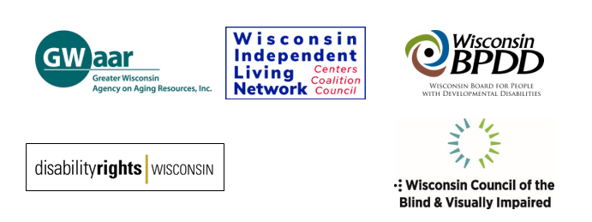

Transportation Budget Motion Request   
for the 2025-27 State Budget

According to the Wisconsin Department of Transportation, 31% of state residents are non-drivers. Non-drivers who live throughout the state include aging adults, youth and adults with disabilities, including those with mental health needs, low-income individuals, students, those without driver’s licenses and those who choose not to drive.

There are several statutorily required programs to provide transportation for seniors and people with disabilities to promote self-sufficiency and well-being. Some programs provide funding for counties or tribes, while others disperse funds to transportation providers and human service agencies for capital expenditures and operations. Many of these programs are unable to meet the demand for rides from this growing population.

Frequently, people with disabilities and older adults cite the lack of transportation options as their top concern, because of the high impact on safety and quality of life. Every day, non-drivers struggle to get to work, obtain medical care, access food or nutrition services, vote, run errands and stay connected to family and friends due to the lack of available, affordable and accessible transportation options. The lack of transportation options is of concern in every part of the state and is a particularly acute issue in our rural communities.

Transportation programs must be funded at levels beyond inflationary growth, specifically:

* County Elderly and Disabled Transportation Assistance Program (85.21) – 10% increase ($1.6M per year).
* Tribal Elderly Transportation Assistance Program (85.215) –
* 10% increase ($44K per year).
* Specialized Transportation Program, includes purchase of Human Service Vehicles, operating budgets, Mobility Managers, coordination and non-vehicle capital (85.22) – 20% increase ($221K per year).
* Urban Mass Transit Operating Assistance (85.20) – 4%increase. ($1.2M in 2025-26 and $6M in 2026-27)
* Paratransit Aids (85.205) – 20% increase ($688K in 2025-26 and $825K in 2026-27).
* Creation of a Transit Capital program - $20,000,000 GPR over the biennium to fund transit-related capital projects.

These funding increases would go a long way to assure that non- drivers can get reliable transportation that enhances the quality of their lives. When non-drivers do better our communities do better.

Respectfully submitted:

Disability Rights Wisconsin

Greater Wisconsin Agency on Aging Resources

Wisconsin Board for People with Developmental Disabilities Wisconsin Coalition of Independent Living Centers

Wisconsin Council of the Blind & Visually Impaired